**5TH YEAR PROJECT REPORT**

**ON**

**BEHAVIORAL GAME THEORY-**

**DESIGN AND TESTING OF A GAME**

**By**

**Ram Krishna Vinayak**

**Registration No.: 20101043**

**IISER, Pune**

**Project Guide:**

**Dr. Varsha Singh**

**IIT, Delhi**

**TAC Member:**

**Dr. Neelesh Dahanukar**

**IISER, Pune**

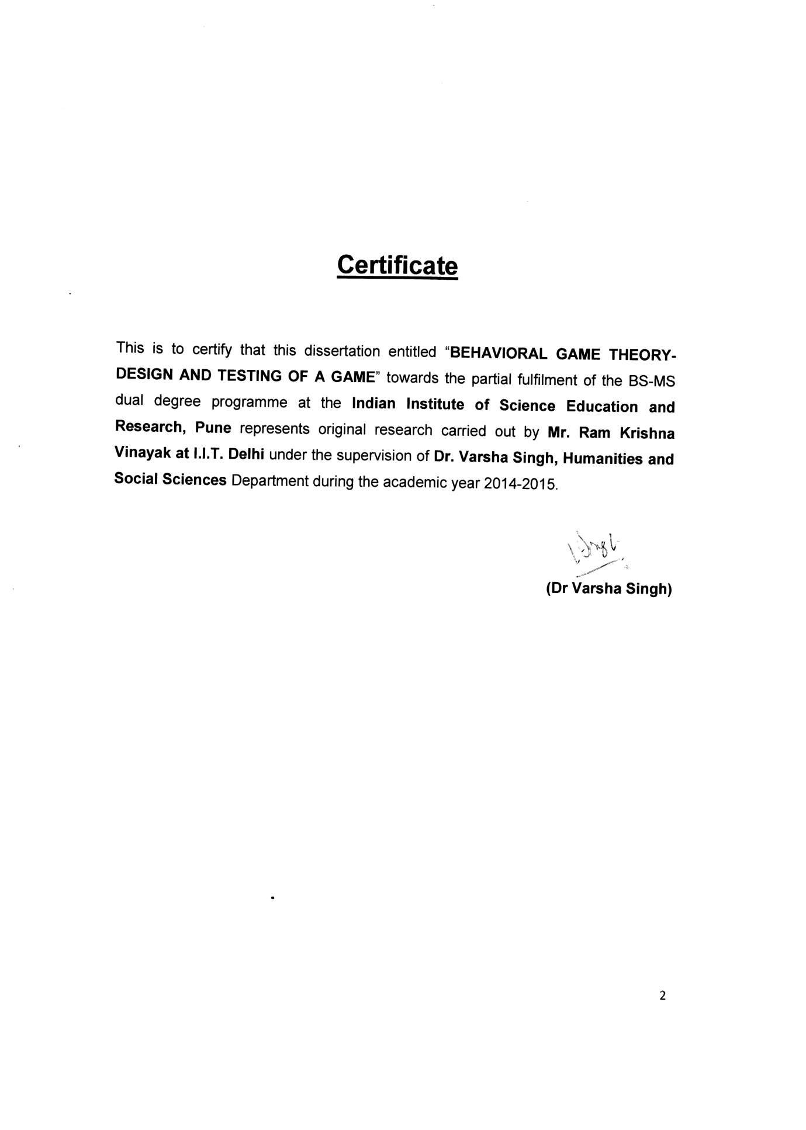

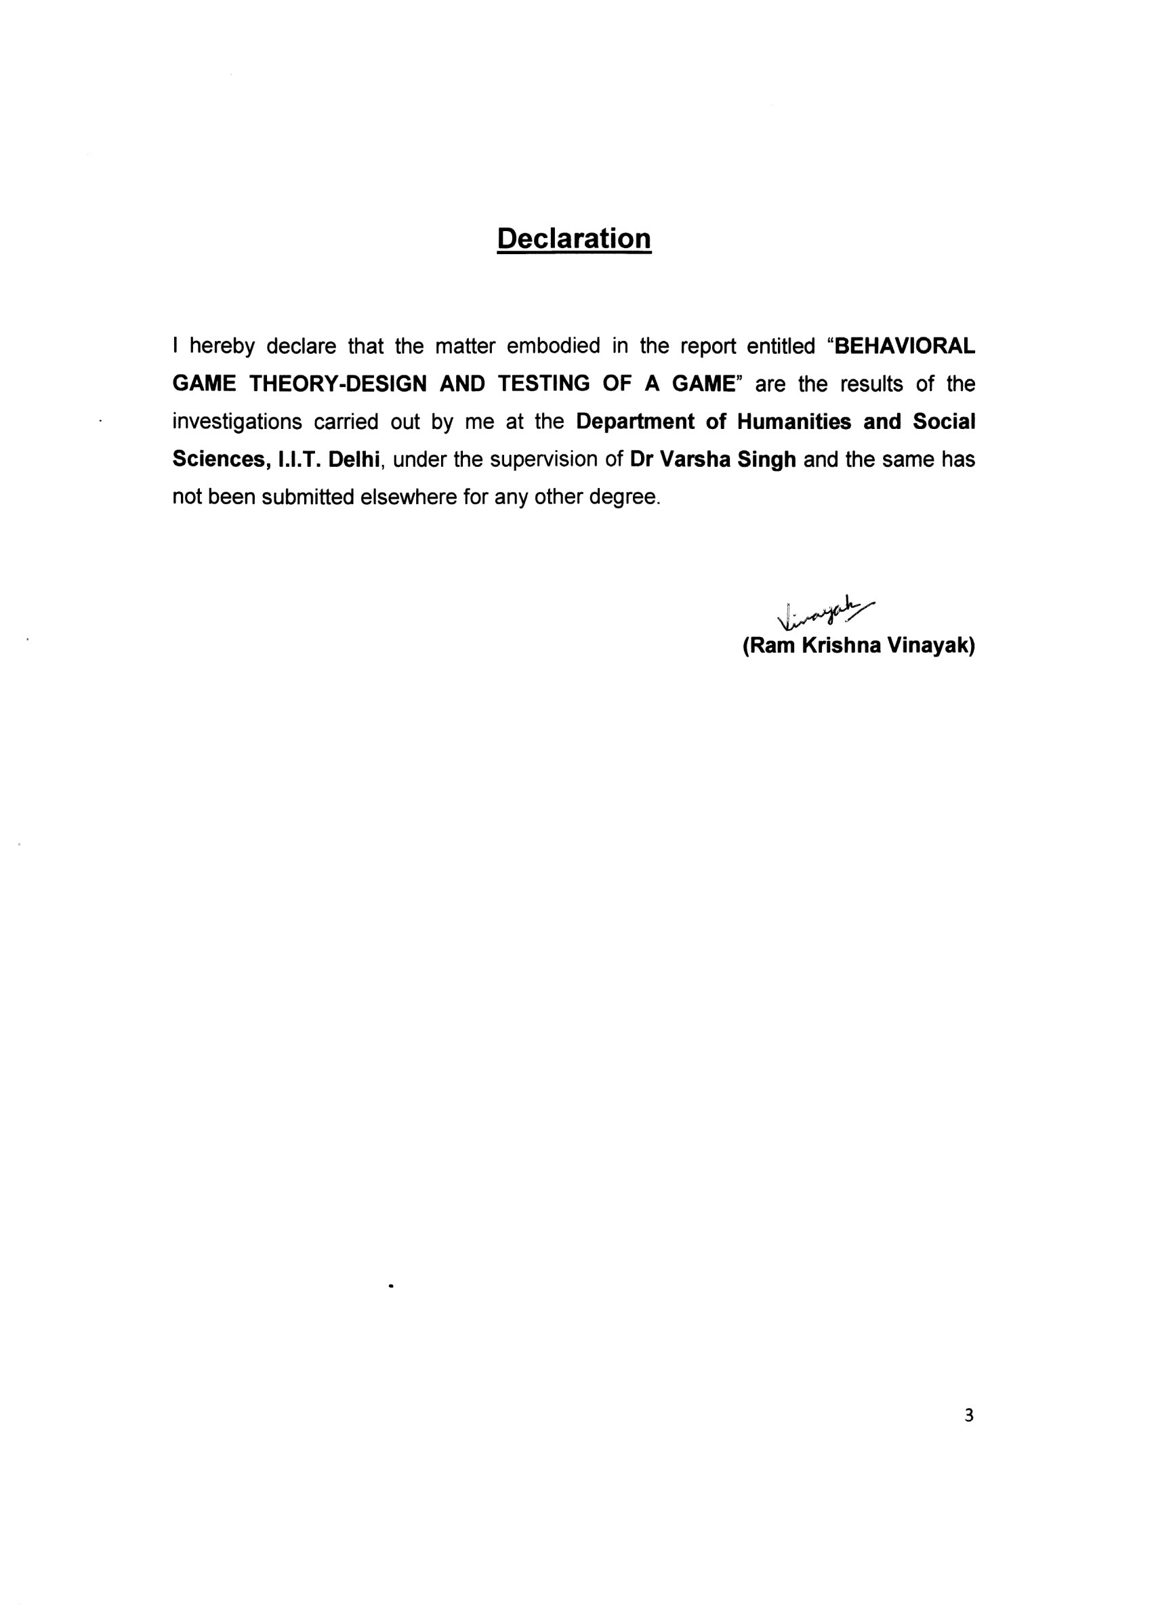

**Abstract**

Earlier, cooperation among humans was considered as very mysterious behavior, but many game theoretic arguments have shown that cooperation in many cases indeed turns out to be an evolutionary stable strategy. Prisoner’s Dilemma game is used to study this. But Altruism still remains a mysterious behavior. Mainly Ultimatum game is used to study altruism. Although Zahavi has given handicap principle, which suggest that people show altruist behavior in order to gain social status. Now the fundamental question remains why people show altruism when there is no scope to gain social reputation. There is not much work done to find factor other than social status responsible for altruism. So we designed a new game called Bliss vs Pleasure to highlight factors other than social status responsible for Altruism. This game is very much realistic because the players are made to play with their own money and the money collected in the society fund of the game, as a result of their altruist behavior moves, is given to the poor and needy children rather than one of the participants in contrast to the case of ultimatum or the dictator game. Indeed the reason here to show altruism is far more realistic than other games. The reason to act selfishly in the game is equally realistic. There are two factors involved in it, first they save their money, and also get back a little fraction of many that we charged for registration and which was used for creating the society fund initially. Secondly, every time they play selfish card, their chance to win the temptation amount increases. Another important feature of this game is that it is iterative, so we are not judging a person based on his single decision. In the end we have also classified our sample into five different classes- altruist class, pseudo altruist class, indecisive class and fluctuating class based on their overall behavior in the game. We have tested that the behaviors of these classes differ from each other significantly. We have also pointed out how these classifications of people can be used to classify people in real life scenario like freedom struggle and corruption in the society.

**LIST OF FIGURES Page No.**

1. Figure-1: Histogram of A, N and S cards (IBP-all 5 sets) 16
2. Figure-2: Histogram of A, N and S cards (IBP-set-1) 16
3. Figure-3: Histogram of A, N and S cards (IBP-set-2) 17
4. Figure-4: Histogram of A, N and S cards (IBP-set-3) 17
5. Figure-5: Histogram of A, N and S cards (IBP-set-4) 18
6. Figure-6: Histogram of A, N and S cards (IBP-set-5) 18
7. Figure-7: Histogram of A, N and S cards (NBP-all 5 sets) 19
8. Figure-8: Histogram of A, N and S cards (NBP-set-1) 19
9. Figure-9: Histogram of A, N and S cards (NBP-set-2) 20
10. Figure-10: Histogram of A, N and S cards (NBP-set-3) 20
11. Figure-11: Box plot of A, N, S - Altruist Class (IBP) 27
12. Figure-12: Box plot of A, N, S - Altruist Class (NBP) 27
13. Figure-13: Box plot of A, N, S - Pseudo-Altruist Class (IBP) 29
14. Figure-14: Box plot of A, N, S - Pseudo-Altruist Class (NBP) 29
15. Figure-15: Box plot of A, N, S - Selfish Class (IBP) 31
16. Figure-16: Box plot of A, N, S - Selfish Class (NBP) 32
17. Figure-17: Box plot of A, N, S - Indecisive Class (IBP) 34
18. Figure-18: Box plot of A, N, S - Indecisive Class (NBP) 34
19. Figure-19: Box plot of A, N, S - Fluctuating Class (IBP) 35
20. Figure-20: Box plot of A, N, S - Fluctuating Class (NBP) 36
21. Figure-21: Box plot of A - different classes (IBP) 37
22. Figure-22: Box plot of A - different classes (NBP) 37
23. Figure-23: Box plot of S - different classes (IBP) 39
24. Figure-24: Box plot of S - different classes (NBP) 39
25. Figure-25: Box plot of N - different classes (IBP) 40
26. Figure-26: Box plot of N - different classes (NBP) 41

**LIST OF TABLES Page No.**

1. Table-1: Equivalence of sets in IBP and NB 13
2. Table-2 : Brief summary of the data 14
3. Table-3: Test for random A, N, S move 14
4. Table-4: Test for Nash equilibrium scenario of A, N, S 21
5. Table-5: Test of internal satisfaction factor 23
6. Table-6: Test of handicap principle factor 24
7. Table-7: Cutoff point for altruist class 25
8. Table-8: Test for difference in the A, N, S - Altruist class 28
9. Table-9: Cutoff point for the Pseudo-Altruist class 28
10. Table-10: Test for difference in the A, N, S - Pseudo-Altruist class 30
11. Table-11: Cutoff point for the Selfish class 31
12. Table-12:Test for difference in the A, N, S - Selfish class 32
13. Table-13: Cutoff point for the Indecisive class 32
14. Table-14: Cutoff point for the Fluctuating class 35
15. Table-15: Test for difference in the A, N, S - Fluctuating class 36
16. Table-16: Test for difference in the A - various class people 37
17. Table-17: Test for difference in the S - various class people 40
18. Table-18: Test for difference in the N - various class people 41
19. Table-19: Test for difference in the A card played in open sets 42
20. Table-20: Test for difference in the N card played in open sets 43
21. Table-21: Test for difference in the S card played in open sets 43

**ACKNOWLEDGMENTS**

I am grateful to my supervisor Dr. Varsha Singh for her continuous support and guidance for the project work. I am also very much thankful to Dr. Neelesh Dahanukar for his inspiration and guidance. My sincere thanks are due to Dr B. Lal, Dr. Aparna Dutt and the faculty members of the Dr B. Lal Institute of Bio-Technology, management and faculty members and students of the Asia Pacific Institute of Management, Subharti Dental College, Jeevna Organizing Committee, without whose support this work couldn’t have been completed.

**INTRODUCTION**

Much of studies on the mechanism of how cooperation evolves and is sustained in human society are done using game theory. A game theoretic approach is better because people tend to respond as per their natural behavior during a game rather than in answering a questionnaire. Prisoner’s Dilemma, ultimatum game, gift exchange or trust game, public goods experiment and tragedy of commons are some of the wildly used games for this purpose. Many extensive works have been done on theory of cooperation using Prisoner’s Dilemma game, both theoretical as well as experimental. Alxelrod (1984) performed a series of computer tournaments in which the game theorists across the world were invited to submit their strategies for Iterative Prisoners’ Dilemma game and Tit for Tat, a strategy submitted by Anatol Rapaport turned out to be most successful strategy.

Further works (Nowak and Sigmund, 1993) showed that strategies like Generous Tit For Tat (GTFT) and PAVLOV can help TFT to spread cooperation in society and were also very successful in the game. So what was common among all these strategies is that they were generous (i.e never starts with a defection), predictable, retaliating and forgiving. These simulations strongly suggest the theory of reciprocal altruism (Trivers, 1971; Axelrod and Hamilton, 1981) which says people cooperate with other people in society expecting that they will help them back when needed. But life is not computer simulation, so Prisoners Dilemma experiments were carried out on real subjects (Sally, 1995). Though reciprocal altruism and strategies like TFT seem to prevail in repeated prisoner’s dilemma game (Axelrod and Hamilton, 1981; Sally, 1995), but what was interesting is that some people were seen to cooperate even when the game was played just once (Cooper, 1996) and there isn’t any known possibility of reciprocation. Now this simply cannot be explained by reciprocal altruism.

Now let’s have a look at another beautiful theory on cooperation given by Amotz Zahavi ( Zahavi, 1995; Roberts, 1998) Altruism as a Handicap: The limitations of Kin Selection and Reciprocity. He considers helping as a selfish behavior. Zahavi has a valid point to make; he says that reciprocal altruism is inherently unstable because in real world interactions are not always simultaneous and may not be reciprocated. Trivers (Trivers, 1971) suggested that reciprocal altruism can be maintained in society if there are adequate mechanism ensure reciprocation. However, such a mechanism is costly to the individual that process it (Zahavi, 1981), hence he will be left behind by the free riders in the Darwinian race. So let us try to view the world from Zahavi perspective. He says that prestige in society can be gained by investing in wasteful characters (Zahavi 1977; Zahavi 1987) as well as by investing in “altruistic” activities. So according to him a person who is indulged in an altruistic act is doing so for his social status (Zahavi, 1995) or as a costly signaling (Gintis et al, 2001). Advantage with this model is that it doesn’t require policing or any other mechanism for sustaining cooperation in society since individuals cooperate for their own selfish interest. Some work has also been done on evolutionary approaches to reputation – based cooperation (Nowak and Sigmund, 1998; Alexander, 1987; Nowak et al, 2000) and games like ultimatum game is extensively used for this with an image building/scoring approach (Nowak and Sigmund, 1998).

It is not necessary that cooperation always evolves for a good cause. In one of the papers titled “collaborating to cheat”, the author has studied about different scandals that have taken place in recent years in different business schools and other institutes of USA. This papers deals with how and why students collaborate together by forming group for solving assignments which was supposed to be done independently and thus cheating with faculty. The author has made a beautiful and simple game theoretic model depicting the situation. He has tried to compute different type of possibilities that occurs in real life situations and has shown us why collaborating to cheat is an optimal strategy for students on the basis of payoff. He also raised the point why some students might not agree to cheat even if it is beneficial to them, this doesn’t imply they are being irrational. Some of them think it is not morally correct to which most of the student indulge in cheating are also convinced with, the difference is that these students value their morality higher than their marks obtained in their utility function order. While some students with very high GPA avoid cheating because of fear of getting poor marks if they get caught. (Briggs et al, 2013)

Another important theory for evolution and sustainability of cooperation in society is the theory of strong reciprocity. Strong reciprocity is a combination of altruistic rewarding and altruistic punishment. Altruistic rewarding has been studied using games like gift exchange game (Fehr, E. et al, 1993), trust game (Hoffman, E. et al, 1994) and sequentially played prisoners dilemma (Hayashi, N. et al, 1999). In both gift exchange and trust game, there is bilateral interaction between two individuals. In both games, one player is trustier and the other is a trustee. Same amount of money is given to both of them in the starting. Now the trustier is asked if he want to transfer any money to the trustee. Whatever he will transfer, will be doubled during the transfer. After trustee received has received the money, he is asked the same question. No transfer is the unique Nash equilibrium for this game. As you can see from the design of the game that there is always scope for the trustee to reward the trustier for his cooperation and it was also observed in studies that more than 50% of the trustier transfer money and their transfer are the higher the more the trustier transferred initially. A sequentially played prisoner’s dilemma is normal prisoner’s dilemma with a slight variation. The variation is that the players don’t play their moves simultaneously, but one after the other. Strong reciprocity is also observed in public goods experiment. It has been shown using this experiment, how a minority of strong reciprocators suffices to discipline a majority of selfish individuals when direct punishment is possible (Fehr, E. and Schmidt, K.M., 1999; Yamagishi, T., 1986; Ostrom, E. et al, 1992; Sethi, R. & Somanathan, E., 1996). So according to this theory, in some environment, a minority of altruist can force a majority of selfish individuals to cooperate using strong reciprocity. This strong reciprocity turns out to be key element in the enforcement of many social norms in hunter – gatherer societies (Kaplan, H. et al, 2000; Hill, K. 2002). In these societies, many times people punish norm violators not for what they did to the punisher but for what they did to others (Bendor, J. and Swistak, P., 2001).

Apart from these there are also many neurobiological studies going on altruism. In these studies, the subject’s brain is scanned using fMRI while they are making decision during games like sequentially played Prisoner’s Dilemma, public goods experiment, etc. These studies show that mutual cooperation and the punishment of defectors activate reward related neural circuits, suggesting that evolution has endowed humans with proximate mechanisms that render altruistic behavior psychologically rewarding. (McCabe, K. et al, 2001; Rilling, J.K. et al, 2002; Adolphs, R., 2003)

**Background:**

I agree to Amotz Zahavi principle of handicap selection extended to the cooperation to some extent that the altruistic behavior is also shown because of the image building and show off business. This may be true for most of the people but I believe that there are a certain number of people who are really motivated for the cause and their altruist behavior is not affected by name and fame. We can classify altruists here as true altruists and pseudo altruists. Some people quite often show altruistic behavior in situations where they just don’t gain anything (i.e no social reputation or anything from the recipient). An ideal example will be a tourist donating money to a blind beggar sitting lonely on a street. Now a natural question arises why someone would beg on a lonely street. So let’s assume that the street is not empty. But even then how does it matter to the tourist, he is a stranger and most likely he will pass that street within a few minutes and might never return again. Or consider a person going for a job interview. On his way he comes across a lad lying on ground with a broken cycle. He is bleeding and unconscious. Now the person helps him to a nearby hospital, missing his interview which cannot be rescheduled. Now the above mentioned two stories are not something overdramatic. People often show altruistic behavior in situations where they know they will gain nothing in terms of material or any type of social recognition for sure. The percentage of these people might be very low in societies, but there are certainly a few of them. In my experiment I would like to distinguish these few people from those who show altruist behavior for social status and will refuse to do so in private. I would call these people who are showing altruistic behavior unconditionally as **“True Altruists (TA)”** where as the other group who show altruism in the presence of society as **“Pseudo Altruists (PA)”**. Since these true altruists are not an inherent part of handicap principle, I have proposed a different extensive hypothesis for human behavior.

**Hypothesis:**

People often show altruistic behavior in the society. This behavior is sometimes driven by gain in social status or is sometimes part of costly signaling. But these are not the only mechanism behind altruist behavior. I feel that there is certain fraction of people in society who are altruist by their true nature. These people show altruist behavior in any circumstances and by doing so also motivate other people to show altruist behavior. Motivation will also affect the behavior of the people.

Moreover, the society consists of a large portion of such people who neither cooperate nor defect but remain indifferent because of the various reasons.

**Objectives of Experiment:**

* To design a new game to investigate that altruist behavior exists in the society.
* To differentiate between true and pseudo altruism within the society.
* To see the effect of additional motivation on altruistic behavior
* To identify different strata of the society on the basis of their level of cooperation.
* To compare the level of cooperation within their group among people willing to show altruistic behavior and willing to show selfish behavior.

**Scope of the Project:**

The work will be limited to mostly the college students with a sample size of 50 to 80. An interesting new game would be design to address the above mentioned objectives. The data will be collected from various places, where the institute administration will allow and people would spare time and money to participate.

**Need for a New Game/Experiment:**

Normally we see broadly three types of people in the society. The three categories are (i) People who cooperate for a good cause/society i.e altruist, (ii) People who defect and go against good cause/society for selfish reasons, and (iii) People who remain neutral/silent i.e neither cooperate nor defect even if they are facing direct or indirect consequences in short or long term.

For instance, in the freedom struggle movement, there were people who struggled for the freedom and can be called cooperators/altruist (cooperating each other and the country as a whole for a good cause), and got punishment ranging from jail, injuries to losing their lives and suffered a lot. The people who helped the rulers can be called as defectors who were rewarded for their services. There were people in large number who remained silent spectator even after facing the consequences in terms of insult and other ailments of ruled in general.

Similarly people protesting /fighting against the corruption in the society, may be considered as the cooperators/altruist to the society. They often lose time and money and may face several problems from the corrupt people, who enjoy their selfish cause and may be considered as defectors. There are again a large number of people who neither cooperate nor defect and remain silent/neutral. Though such people are not directly involved in corruption but indirectly support the corruption. Within this neutral group also we will try to classify people further on the basis of the reason of their responses.

As you can see above, most of the time we can divide people into three broad categories depending on their choice of action. But it may be noted here that most of the games used to study the altruist or cooperative behavior of the people like prisoner's dilemma, ultimatum game, dictator game and tragedy of commons, none of these give all three (i.e to show altruism, remain neutral, show selfishness) options to the players. Prisoner's dilemma and the ultimatum game gives the player the option to behave cooperatively, altruistic or selfishly. So, a new game has been designed here called Bliss vs Pleasure in which the above three categories can be considered as three options before a player.

**MATERIALS AND METHODS**

**Design of a new game (Bliss vs Pleasure):**

A new game was designed to reflect the behavior of the society specially the three broad categories as altruist, defector or selfish and neutral. Several brain storming sessions were done and various types of new games were conceived with different payoff matrices and varying number of players at a time and numerous rewarding policies. But finally a game named Bliss vs pleasure was selected for the purpose which is described below.

Bliss vs Pleasure studies the above mentioned objective. The game distinguishes between people showing true altruist behavior and people showing it as show off business under different circumstances, neutral behavior and selfish behavior. This game not only looks at the overall behavior of the individuals, but also checks the ability of people to come together and work as a group. It also tries to see the trend in the society that who is able to motivate the people mostly showing neutral behavior, the altruist group or the selfish group in order to seek their cooperation when needed.

**How to play:**

Before start of the game, each participant is said to deposit Rs.150/- in which Rs.50/- is considered as registration money were as Rs.100/- for playing the game. For playing the game, participants are given a temptation that they can win up to Rs.3000/- cash in the game. In the game we have a society fund and the collected registration money from all the participants is kept in that. The money that will be collected in the society fund at the end of the game will be donated for the scholarship of the poor children. The game consists of 25 rounds, which is split into five different sets as per requirement of our experimental study. Each player is given 3 cards namely A, N and S which will be used by him in every round. Now the A card stands for altruistic move, the N for being neutral and the S card for a selfish move. The player is free to play any of the three cards in a round of the game. If a player chooses to play A card in a round, he will be donating Rs.5/- to the society fund which will be reduced from Rs.100/- deposited by him in the starting. If he chooses to play N in a round, he will be essentially doing nothing. If he chooses to play S card in a round, he will receive Rs.2/- from the society fund. So if a player plays S in all 25 rounds of the game, he can take back his Rs.150/-.

**Five Sets of the Game:**

The 25 rounds of the game are split into five sets. The set 1 consists of three rounds. In set 1 the participants are asked to play their card confidentially in private. Purpose of this set is to note down true behavior of the individual. After the set, the participants are shown a motivation audio visual and set 2 is played with them. The set 2 is exactly same as set 1. In set 2 we try to figure out the effect of additional motivation of true behavior of the individuals. Then participants are made to sit into groups. Male and females are made to sit into separate groups. Now set 3 is played with them. This set has seven rounds and in this set, your move is visible to all the other players of your group. Aim of this set is to see the change in behavior of an individual due to the presence of society. Afterwards regrouping is done for the next set. But this time it is made sure that each group has both male and female population. Set 4 is played in the same fashion as set 3. This set is designed to see if there is some change in behavior of an individual due to the presence of opposite sex. At the end we have set 5. This set consists of five rounds. In this set players are said to form groups of their own. This set is designed to study the cooperative behavior among the altruist for a good cause and their ability to convince the others for it.

**Payoff and Utility Function:**

This game is played at two levels by the players. One with the society where others are watching their move, and the other within themselves in their minds where different factors of the payoff in the game are playing their roles. Let us first define the utility function involved in this game.

As we have discussed above a player has three choices in this game A, N and S. We have considered here three factors/functions which play role in deciding their choice in the game. The first one is the monetary factor which is obvious and has fixed values for the variables A (-5), N (0) and S (+2) for each player. The other factor is the handicap principle factor which includes the social status and the costly signaling factor which vary for each individual. The third factor is the internal satisfaction factor which one gets while cooperating for a good cause and which is independent of the other two factors. This factor also varies in degree for each individual.

U(x) = i(x) + h(x) + m(x)

Where, x = variable having values A, N or S

I(x) = internal satisfaction factor;

h(x)= handicap factor

m(x)= monetary factor

The payoff P(U) = [i(A)+h(A)+m(A)]\*nA + [i(N)+h(N)+m(N)]\*nN + [i(S)+h(S)+m(S)]\*nS

nA, nN and nS are the number of A, N and S card played by the player.

Details regarding rules and regulations of the game are given below:

**General Instruction for Bliss vs Pleasure:**

The game consists of five sets. Instructions regarding the set will be given at the beginning of the set. In each round you have to choose a strategy. You can get up to Rs.2000/- on the basis of first four sets of the game and Rs.1000/- in the fifth set. Money collected at the end of the game in the society fund, will be used for charity.

You have to deposit Rs.50/- registration fee before the start of the game. You have to deposit Rs.100/- as security deposit before start of the game. This will be returned to you at the end of the game as per the rules of the game.

You have following strategy choices for each round of game: Altruism (A), Neutral (N) and Selfish(S)

**Playing Rules:**

If you choose altruism strategy (A card), then you have to donate Rs.5 in the society fund.

If you choose selfish strategy(S card) then you will take RS.2 from the society fund.

If you choose neutral strategy, then neither you donate nor do you take any money from the society fund.

The game is played with the help of cards and marbles. The money equivalent to the marbles/points that you donate for society fund will be deducted from your security money (i.e Rs.100) and similarly equivalent to the marbles taken by you will be given to you at the end of the game. Each marble/point is worth Re.1.

**Rules regarding distribution of temptation money:**

* At the end of first four rounds the amount of Rs.2000/- will be split into two parts, the altruist and the selfish part according to following rules:

Money in altruists part : selfish part :: Total number of altruist moves : selfish moves

(money in altruists part)/(money in selfish part) = (number of altruist moves)/(number of selfish moves)

* The altruist part of the money will go the society fund.
* The selfish part of the money will be given to one of the participant by a lottery based on a probability function P(i).
* P(i) - Probability of player i winning the lottery = (number of times player i choose selfish in first four sets)/ (sum of number of times selfish strategy is chosen by all players in first four sets)
* The temptation amount of Rs.1000/- will either be donated in the society fund or will be given to one of the participant as per probability function on the basis of fifth set of the game. .
* If no group member chooses to defect in any round of the game in a group in set-5, then it will be defined as altruist group.
* If majority of groups are altruist group then the temptation amount Rs.1000/- will be donated to the charity.
* If majority of the groups aren’t altruist then the temptation amount Rs.1000/- will be awarded to one of the participant by a lottery based on a probability function P5(i).
* P5(i) - Probability of player i winning the lottery = (number of times player i choose selfish in the fifth set)/ (sum of number of times selfish strategy is chosen by all players in the fifth set)
* In case of tie between groups, matter will be resolved by a coin toss.

**Procedure:**

The experiment consists of five sets. A set of instructions which includes general instruction, playing rules, introduction to Bliss vs Pleasure game and rules regarding distribution of money were given to the participants along with a set of three card A, N and S before beginning of the experiment. Then the five sets were played in order as per their name set1, set2 etc. The rules regarding each set were announced in the beginning of the set as instructions for set x. (For details of instructions, please refer to the appendix).

The set 1 consists of three rounds. In this set the subjects were isolated with each other and their responses were taken for all the three rounds without revealing it to others. This set aimed at capturing the true and inherent behavior of an individual.

Now the subjects were shown a motivational audio visual and then set 2 was conducted. This set is same as set 1 and tries to measure the effect of motivation.

After that subjects were made to sit in groups. These groupings were random; and males and females were made to sit into separate groups. Then set 3 was conducted. This set consists of seven rounds. In this set, moves on an individual are not kept confidential. This set aimed at studying the behavior of individuals in the presence of society of same gender on the responses.

Next the participants were regrouped. This regrouping was also random and it was made sure that this time each group had some males and some females. Now set 4 was conducted in the same manner as set 3. In this set the effect of costly signaling was observed in the responses.

The basic purpose of set 3 and set 4 is to look at the effect of handicap principle i.e to see if pseudo altruism emerges among participants in the presence of society.

Finally we conducted set 5. This set was having five rounds. This set had some different rules and temptation amount (for details see the appendix). In this set the participants were asked to form the groups of their own. This set aimed to compare the group forming abilities of the altruist and the selfish participants.

**Feedback and revised new game:**

The game was conducted in two different colleges, one in Jaipur and other in Delhi. Total 82 college students out of which 37 males and 45 females participated in the game. Their age ranged from 17 to 24 years with mean 20.41years and SD 1.94. They were classified in 4 different income groups as per norms of government of India survey. These are Below Rs.12,000/- per month- 11 students, Rs. 12,000/- to Rs. 30,000/- per month- 21 students, Rs. 30,000/- to Rs. 1,50,000 per month -35 students and above Rs.1,50,000/- per month -15 students. The students knew each other.

The overall output of the game was very encouraging and has been presented in the result and discussion. But we found that the game was taking little longer time and the college administration sometimes requested to finish it in two hours. Few students mentioned this in their feedback Performa also that the number of rounds in 3rd and 4th set should be reduced to make it more interesting. Hence it was decided to revise the game in the light of the feedback received from the students and the experience gained by us.

**New Bliss vs Pleasure (NBP) game:**

It was decided to reduce the overall number of rounds from 25 to 15. We found from the analysis of the data that the effect of additional motivation was not significant on the whole group hence set-2 was removed. To make it uniform the confidential set-1 was made of five rounds. Set-3 was also removed as there was not much difference in set-3 and set-4. Set -4 was retained as it was covering social status and costly signaling factor both in the name of handicap principle factor. Set-4 was also made of five rounds. Set-5 was kept as it is containing five rounds except for the little change in the group behavior study.

Now in set -5 it was decided that after each round in a group, cards played by all the players will be collected and reshuffled and one card out of pack will be taken by one of the players. The card thus selected will decide the marking of the group for that round. Suppose in a group after first round S card is drawn by any player, hence the S will be taken as the mandate for that round. Similarly suppose that the cards in other 4 rounds come out to be A, A, S, S. Hence we can see that in the 5th set the score of the group is 3S and 2A. Hence S will win for that particular group.

Set-4 was also made little more interesting as after playing each card by a player a dice was also thrown by him/her. The value obtained on the dice was multiplied to the score of the card played by the player for their calculation of probability distribution for winning the lottery and splitting the prize money in the ratio of altruist /selfish. But the amount to be paid by altruist or selfish move was unaltered. Hence it didn’t essentially changed the basic design of the game but only made the game more compact and interesting.

So basically in the new game there are only three sets as two sets were removed. We will call the earlier Bliss vs Pleasure game as Initial Bliss vs Pleasure (IBP) game and the revised one as New Bliss vs Pleasure (NBP) game. There is no difference in the basic design of the game. Equivalence of sets in both the games is given below.

**Table-1: Equivalence of sets in IBP and NB**

|  |  |  |
| --- | --- | --- |
| **Type** | **IBP** | **NBP** |
| Confidential Set | Set-1 and Set-2 having 3 rounds each | Set-1 of 5 rounds |
| Open Set | Set-3 and Set-4 of 7 rounds each | Set-2 of 5 rounds |
| Group Set | Set-5 of group of 5 rounds | Set-3 of group of 5 rounds |

**RESULT AND DISCUSSION:**

**Data Collection:**

The Bliss vs Pleasure game was conducted at five different places including three colleges. Data collected from various colleges and organizations in the game have been presented in tabular form in Annexure-I.

The Initial Bliss vs Pleasure (IBP) game was played in two colleges namely Dr. B. Lal Institute of Biotechnology (referred to Dr Lal in the thesis), Jaipur and Asia-Pacific Institute of Management (referred to Asia Pacific in the thesis), New Delhi. 45 students participated at Dr Lal and 37 students participated at Asia Pacific in the game. The combined data (82 participants) of both the institutes are referred as “dljp” in the program code. The combined data is given in the tabular form in csv format (dljp) in Annexure-I. The program code (dljp.R) in R has been given in Annexure-II.

The new or revised Bliss vs Pleasure (NBP) game was played at three different places namely Subharti Dental College (refferd to subharti in the thesis), Meerut, Chetna Workshop (reffered to chetna in the thesis), Bijnor and Jeevna Workshop (referred to jeevna in the thesis), Jaipur. There were 58 participants at subharti, 17 at chetna and 10 at jeevna. The combined data (85 participants) of all the three places are referred as “nb” in the program code. The combined data is given in the tabular form in csv format (nb) in Annexure-II. The program code (nb.R) in R has been given in Annexure-III.

**Table-2 : Brief summary of the data**

|  |  |  |
| --- | --- | --- |
| **Game** | **IBP** | **NBP** |
| **Photo** | **D:\VINAYAK\Game Theory\experiment\Collages\B Lal Collage\photos\20140823_180018.jpg** | **C:\Users\Vinayak\Downloads\image(5).jpg** |
| **Number** | Total: 82; Females: 45; Males: 37 | Total: 85; Females: 60; Males: 25 |
| **Age** | Mean: 20.41 yrs; Median: 21.0 yrs  Min:17yrs; Max: 24yrs; sd:1.95; mad:2.22 | Mean: 24.4 yrs; Median: 19.0 yrs  Min:16yrs; Max:70yrs; sd:12.88; mad:1.48 |

**Data Analysis of Bliss vs Pleasure Game (dljp data):**

1. **Chi squared Goodness of Fit test of A N S distribution:** This test has been done on the total A, N and S card played by the participants in the game to see whether the cards have been played randomly or it depicts the choice of an individuals. It may be noted here that participants can only play any one card in every round and hence A, N, and S card options are mutually exclusive in each round.

**Table-3: Test for random A, N, S move by the participants**

|  |  |  |  |  |  |  |  |  |  |  |  |  |  |  |  |  |  |  |  |  |  |
| --- | --- | --- | --- | --- | --- | --- | --- | --- | --- | --- | --- | --- | --- | --- | --- | --- | --- | --- | --- | --- | --- |
| |  |  |  | | --- | --- | --- | | **Game** | **Initial Bliss vs Pleasure** | **New Bliss vs Pleasure** | | **Test** | **Chi squared Goodness of Fit test of A N S distribution including all sets for its randomness** | | | **Null Hypothesis** | People randomly choose A, N, S | | | **Alternative Hypothesis** | People don't choose A,N,S randomly but it depends on the choice of the individual which shows their behavior pattern. | | | **Claim** | Tested against the probability distribution (1/3, 1/3, 1/3) | | | **Actual Values** | (558, 367, 1123) | (395, 154, 576) | | **Result** | X-squared = 452.7549,  df = 2, p-value < 2.2e-16  Null hypothesis rejected | X-squared = 239.0453,  df = 2, p-value < 2.2e-16  Null hypothesis rejected | |
|  |
| |  | | --- | |  | |

It can be seen that p-value is much less than 0.05 in both games and hence null hypothesis is rejected. It shows that participants have not played the game randomly. It indicates that participants have played the game seriously as per their choice and the game has been able to bring out their behavior in the form of their choices.

1. **Distribution Pattern of A,N,S:**

The distribution pattern of A, N and S card played by the Dr Lal and Asia Pacific students in all sets and in different sets are given separately in figure no. 1 to 6 for the initial bliss vs pleasure game. Similarly the distribution patterns of the same for new bliss vs pleasure game played by subharti, chetna and jeevna are given below in figure no. 7 to 10.

It can be seen that most of the patterns of A and N card are positively skewed. At the same time distribution patterns of S card are either negatively skewed or approximately normal or bipolar.

This shows an overall tendency of the students towards S, selfish card. Set-5 depicts group behavior of the participants. It may be noticed here that neutral N cards are reduced in set-5 and the distribution of S, selfish card becomes bipolar. This indicates that because of group mentality the indecisive cards reduce and they go towards A, altruist or S, selfish cards.

**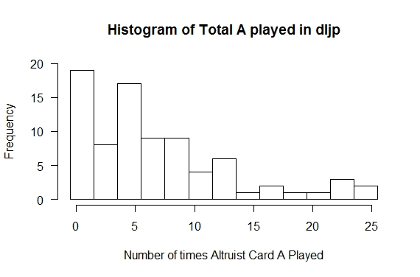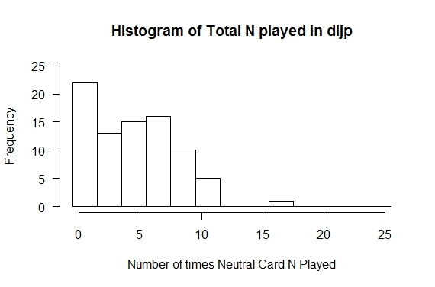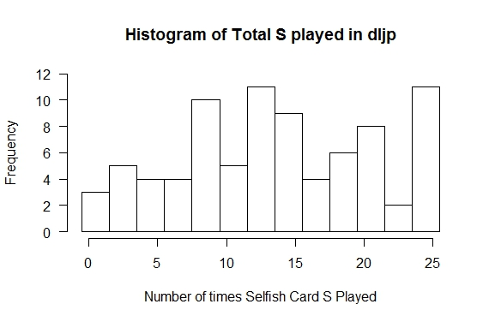**

**Figure-1: Histogram of A, N and S cards played by Dr Lal and Asia Pacific students including all 5 sets**

**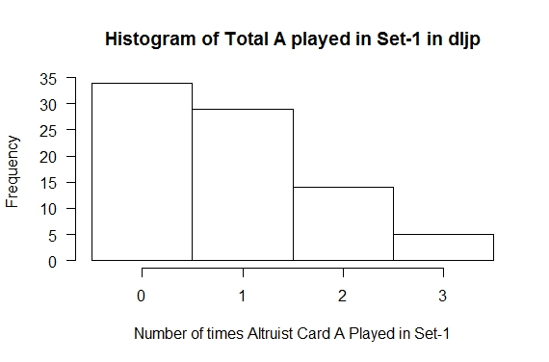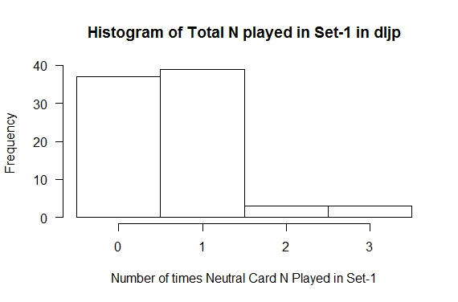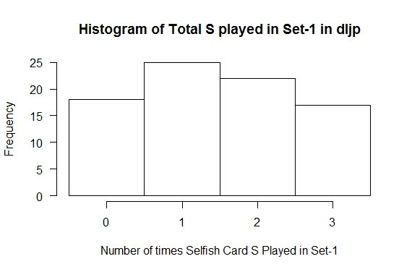**

**Figure-2: Histogram of A, N and S cards played by Dr Lal and Asia Pacific students in Set-1**

**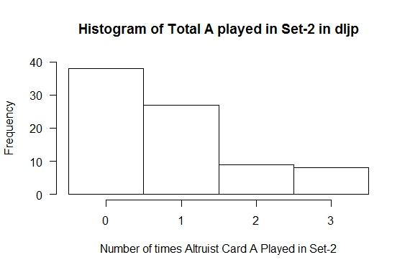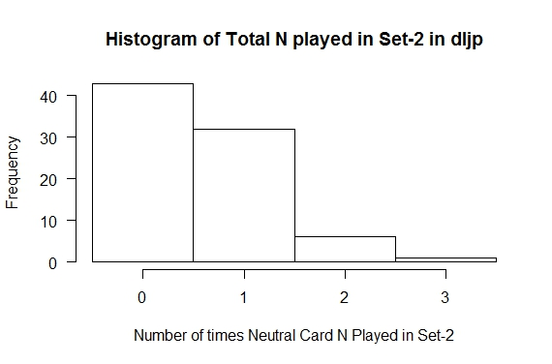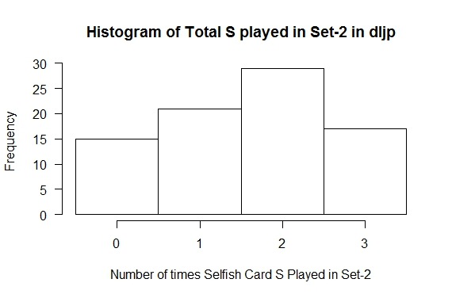**

**Figure-3: Histogram of A, N and S cards played by Dr Lal and Asia Pacific students in Set-2**

**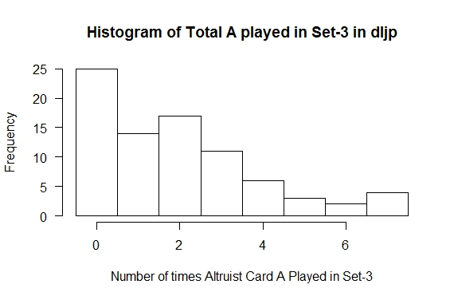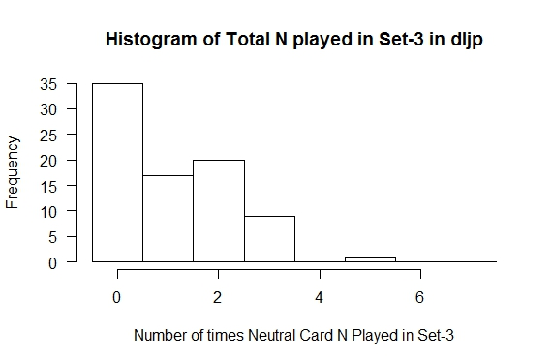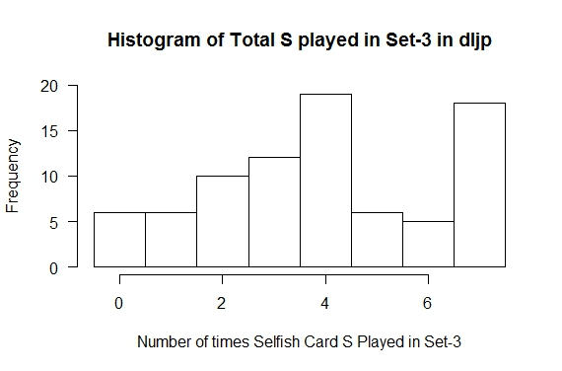**

**Figure-4: Histogram of A, N and S cards played by Dr Lal and Asia Pacific students in Set-3**

**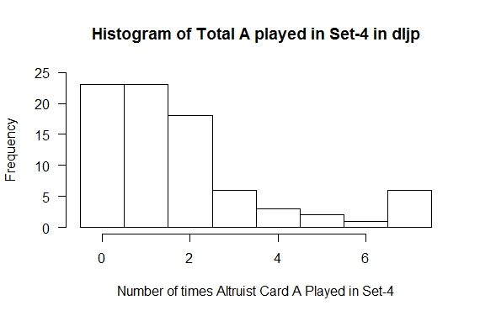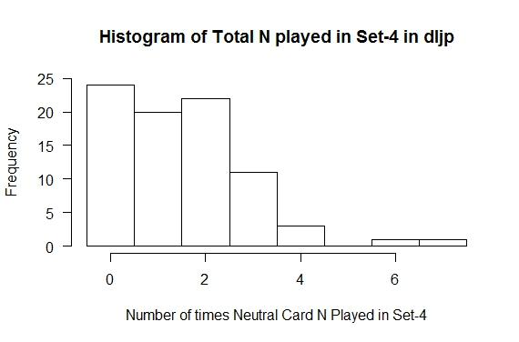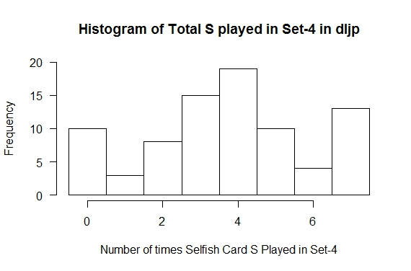**

**Figure-5: Histogram of A, N and S cards played by Dr Lal and Asia Pacific students in Set-4**

**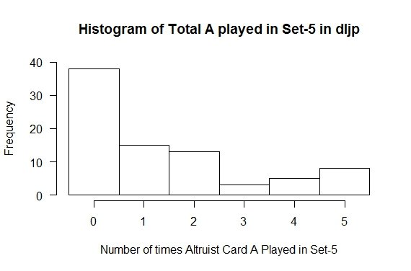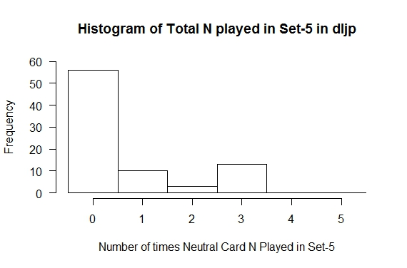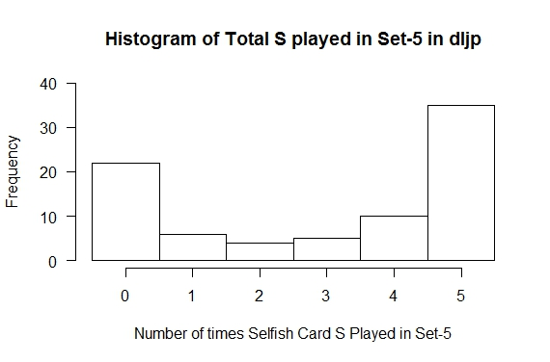**

**Figure-6: Histogram of A, N and S cards played by Dr Lal and Asia Pacific students in Set-5**

**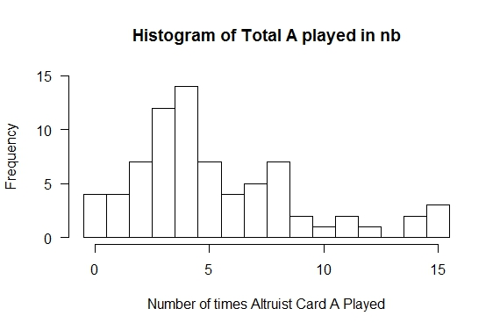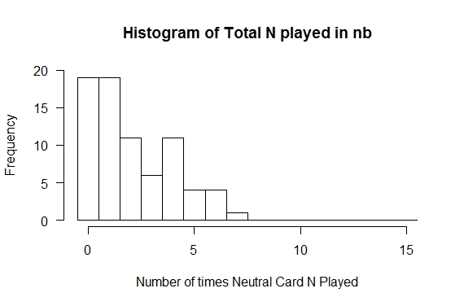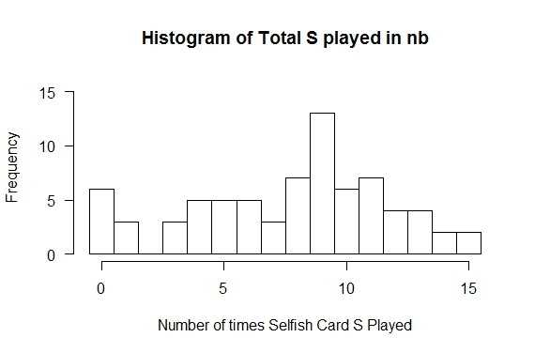**

**Figure-7: Histogram of A, N and S cards played by subharti, jeevna and chetna participants including all 5 sets**

**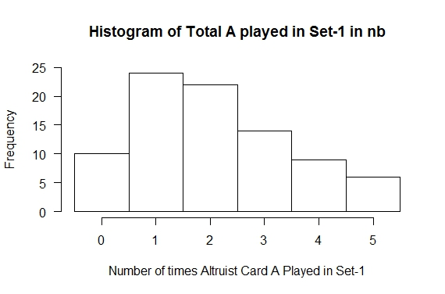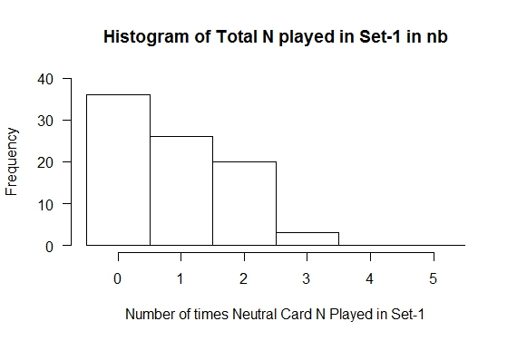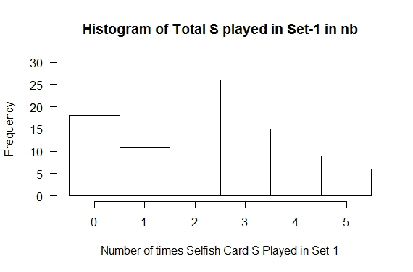**

**Figure-8: Histogram of A, N and S cards played by subharti, jeevna and chetna participants in set-1**

**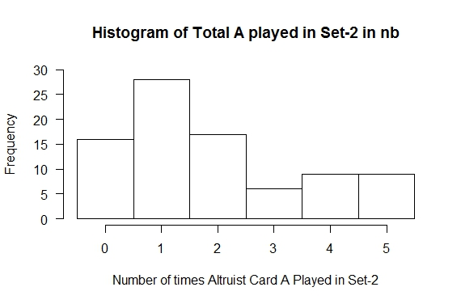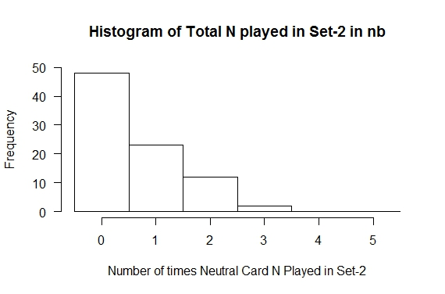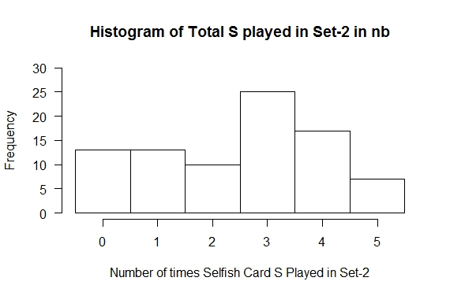**

**Figure-9: Histogram of A, N and S cards played by subharti, jeevna and chetna participants in set-2**

**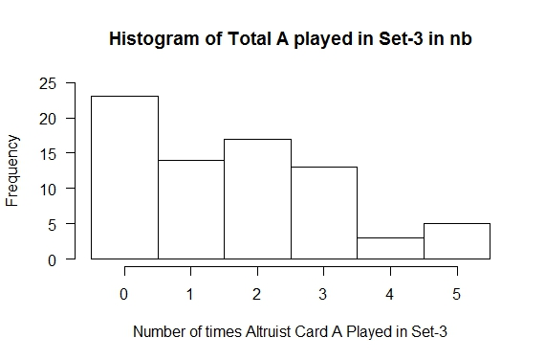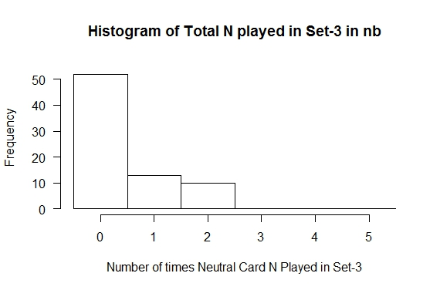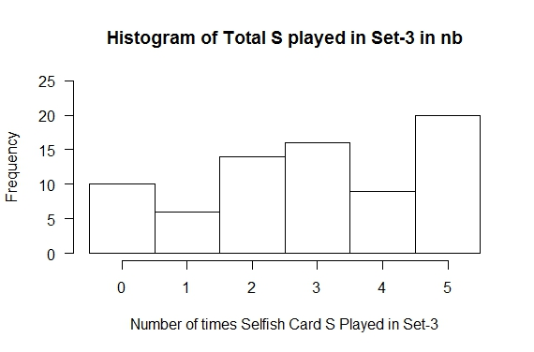**

**Figure-10: Histogram of A, N and S cards played by subharti, jeevna and chetna participants in set-3**

1. **Test of existence of factors other than monetary in the utility function:** We have hypothesized and defined the utility function of the game above. We are going to test here the existence of factors other than monetary factor by supposing that the other factors don’t exist and only monetary factor is there. (Proof by contradiction).

P(U) = [i(A)+h(A)+m(A)]\*nA + [i(N)+h(N)+m(N)]\*nN + [i(S)+h(S)+m(S)]\*nS

In the above payoff value, suppose in utility function of any arbitrary individual:

i(A) = i(N) = i(S) = h(A) = h(N) = h(S) = 0,

Then, P(U) = m(A)\*nA + m(N)\*nN + m(S)\*nS

Here values are m(A) = -5; m(N) = 0; m(S) = 2,

Hence, P(U) = 2\*nS – 5\*nA

Nash equilibrium for maximizing the payoff value in any case would be clearly maximizing nS, number of S card played and minimizing nA, number of A card played. Nash equilibrium in this condition say that one should only play S, selfish card in this game. Hence ideally the probability distribution function of A, N, S cards should be (0, 0, 1). Let us test this distribution by chi-square test. Let us also assume some 2 to 10 percent error in playing the cards. This also helps us in putting the minimum number of expected value in a cell i.e.5 for the chi-squared test. So the probability distribution will be taken as (0.02, 0.02, 0.96) for testing.

**Table-4: Test for Nash equilibrium scenario of A, N, S**

|  |  |  |
| --- | --- | --- |
| **Game** | **Initial Bliss vs Pleasure** | **New Bliss vs Pleasure** |
| **Test** | **Chi squared Goodness of Fit test of A N S distribution including all sets for existence of factors other than monetary in the utility function** | |
| **Null Hypothesis** | The utility function only has monetary factor. All players play for money only. | |
| **Alternative Hypothesis** | Factors other than monetary also exist in the utility function. All don’t play for money only. | |
| **Claim1 (A,N,S)** | Tested against the probability distribution (0.1, 0.1, 0.8) | |
| **Actual and expected Values** | (558, 367, 1123)  (204.8, 204.8, 1638.4) | (395, 154, 576)  112.5, 112.5, 900) |
| **Result1** | X-squared = 899.7252, df = 2, p-value < 2.2e-16  Null hypothesis rejected | X-squared = 841.3378, df = 2, p-value < 2.2e-16  Null hypothesis rejected |
| **Claim2 (A,S)** | (0.1, 0.9) | (0.1, 0.9) |
| **Result2** | X-squared = 1004.838, df = 1, p-value < 2.2e-16  Null hypothesis rejected | X-squared = 1015.499, df = 1, p-value < 2.2e-16  Null hypothesis rejected |

It can be seen here that the p-values in both games are much less than 0.05 and hence null hypothesis is rejected. This negation proves that there are factors other than monetary in the utility function. The actual values are nowhere near to the expected even if we have considered 2% error which is too conservative. If error is less the p-value would be smaller. Even if we consider only A and S for the Chi-squared test because N has no role in the payoff value, similar result is obtained. It can be seen in the table above.

1. **Test of existence of Internal Satisfaction factor in the Utility Function:** The first and second set of the IBP game and 1st set of NBP game was having confidential card playing in the rounds. Since others were not able to know which card a player is playing, the value of handicap factor should be 0 for these sets. Hence the payoff value of any arbitrary individual would be:

P(U) = [i(A) + m(A)]\*nA + [i(N) + m(N)]\*nN + [i(S) + m(S)]\*nS

Let us assume that Internal Satisfaction factor is not a factor in the utility function.

* i(A) = i(N) = i(S) = 0
* P(U) = m(A)\*nA + m(N)\*nN + m(S)\*nS

Putting the values m(A) = -5; m(N) = 0; m(S) = 2

* P(U) = -5\*nA + 2\*nS

This is the same function as we found in the earlier test but now we have to test it for the first two sets in IBP game and for the first set in NBP game only. Similar arguments follow here that obviously to maximize the payoff value Nash equilibrium would be to play S card only in all the rounds. Again 2% error has been considered here in playing the cards.

**Table-5: Test of internal satisfaction factor**

|  |  |  |
| --- | --- | --- |
| **Game** | **IBP** | **NBP** |
| **Test** | **Chi square Goodness of Fit test of A N S distribution for Nash equilibrium in Set-1 & 2 for IBP game and in Set-1 for NBP game** | |
| **Null Hypothesis** | People play selfish card mostly in the confidential rounds. True altruism is negligible. | |
| **Alternative Hypothesis** | People play altruist card also in the confidential play showing internal satisfaction factor in the utility function. | |
| **Claim1 (A,N,S)** | Tested against the probability distribution (0.1, 0.1, 0.8) | |
| **Actual and expected Values** | (141, 101, 250)  (49.2, 49.2, 393.6) | (155, 70, 150)  (37.5, 37.5, 300) |
| **Result1** | X-squared = 278.2134, df = 2, p-value < 2.2e-16  Null hypothesis rejected | X-squared = 471.3333, df = 2, p-value < 2.2e-16  Null hypothesis rejected |
| **Claim2 (A,S)** | (0.1, 0.9) | (0.1, 0.9) |
| **Result2** | X-squared = 1004.838, df = 1, p-value < 2.2e-16  Null hypothesis rejected | X-squared = 1015.499, df = 1, p-value < 2.2e-16  Null hypothesis rejected |

p-values for both the games are very much lower than 0.05 which indicates rejection of null hypothesis. It proves that internal satisfaction factor is there in the utility function and clearly visible in the confidential sets of the games. It can also be seen that if the value of N is removed from the test because of its absent role in the utility function in result2, that the null hypothesis have been rejected.

1. **Test of existence of Handicap Principle factor in the Utility function:** Existence of handicap principle factor is tested similar to the previous two tests. Chi-squared Goodness of Fit test of set-3&4 combined for IBP game and 2nd set for the NBP game have been done for the participants who haven’t played A card even once in the first two sets in the IBP game and in 1st set in the NBP game. The internal satisfaction factor can be assumed zero for the participants who haven’t played A card even once in the confidential sets. Suppose if handicap principle factor (social status + costly signaling factor) is also negligible then they shouldn’t play A card in the open sets.

Again the distribution of A, N, S card played in the open sets by the participants not playing any A in the confidential sets are tested against the claim (0.02, 0.02, 0.96) and for A and S against (0.02, 0.98) probability distribution.

**Table-6: Test of handicap principle factor**

|  |  |  |  |
| --- | --- | --- | --- |
| **Game** | **IBP** | **NBP** | |
| **Test** | **Chi square Goodness of Fit test of A N S distribution for Nash equilibrium in open sets for the participants who haven’t played any A card in the confidential sets.** | | |
| **Null Hypothesis** | handicap principle (social statue + costly signaling) factor is negligible in the utility function. | | |
| **Alternative Hypothesis** | There exists handicap principle factor in the utility function. | | |
| **Claim1 (A,N,S)** | (0.1, 0.1, 0.8) | | (0.1, 0.1, 0.8) |
| **Actual and expected Values** | (18, 42, 275 )  (33.5, 33.5, 268) | (15, 5, 30)  (5, 5, 40) | |
| **Result1** | X-squared = 9.5112, df = 2, p-value = 0.008603  Null hypothesis rejected | X-squared = 22.5, df = 2, p-value = 1.301e-05  Null hypothesis rejected | |
| **Claim2 (A,S)** | (0.1, 0.9) | (0.1, 0.9) | |
| **Result2** | X-squared = 4.8422, df = 1, p-value = 0.02777  Null hypothesis rejected | X-squared = 27.2222, df = 1, p-value = 1.814e-07  Null hypothesis rejected | |

|  |
| --- |
|  |
| |  | | --- | |  | |

It can be seen that p-values much lower than 0.05 reject the null hypothesis ensuring the existence of handicap principle factor in the utility function.

1. **Identification of Classes:** It has been seen that the participants have played their cards as per their choices and the values they assign to their internal satisfaction factor, social status and costly signaling apart from the monetary values for playing the particular card. We have tested the data and found that factors other than monetary are there in the utility function.

We can classify the participants on the basis of the values they assign to various factors for A N and S cards. Naturally those who assign higher values to the internal satisfaction factor i(x) than other factors belong to Altruist class. Similarly we have identified the following classes and evolved a formula for drawing the cutoff points based on their Median and MAD (Median Absolute Deviation).

Median and mad have been used in place of mean and sd in the formula for cutoff point because most of the distribution patterns of data are not normal and hence non-parametric. The formula used here mostly is:

Cp = Int(max(m + mad, 0.5\*mp)

Where, Cp = Cutoff point

Int = nearest integer (function)

max = maximum of the values within parenthesis.(function)

m = median

mad = median absolute deviation = median(|x-median(x)|)

mp = maximum possible score

**Altruist Class:** Altruists assign higher values to internal satisfaction factor than the handicap and monetary factors. So in order to find people falling in this class, we will be using two cutoffs using the Cp function defined above. First cutoff we will define on Total A excluding the last set. If one qualifies that we will check him for second Cp defined on total A of set 1 and set 2 for IBP and set 1 of NBP. A person qualifying both these cutoffs is considered to fall in the Altruist Class. Our first cutoff makes sure that the person is Altruist; the second cutoff is used to make sure that people are showing altruism for their internal satisfaction.

**Table-7: Cutoff point for altruist class**

|  |  |  |
| --- | --- | --- |
| **Game** | **IBP** | **NBP** |
| Histogram of A card played in all the sets except the last one | D:\VINAYAK\Game Theory\experiment\dljp-graph\1234A.jpeg | D:\VINAYAK\Game Theory\experiment\nb-graph\12A.jpeg |
| **Boxplot** | **D:\VINAYAK\Game Theory\experiment\dljp-graph\1234Abp.jpeg** | D:\VINAYAK\Game Theory\experiment\nb-graph\12Abp.jpeg |
| **Cutoff point 1** | MedianA1234i = 4; MADA1234i = 4.4478; mp1234i = 20/2=10; Cpa1i = int(max(4+4.45, 10)) = 10 (80th %) | MedianA12n = 4L; MADA12n=2.9652; mp12n=10/2 = 5  Cpa1n = int(max(4+2.97, 5)) = 7 (84th %) |
| Histogram | D:\VINAYAK\Game Theory\experiment\dljp-graph\12A.jpeg | D:\VINAYAK\Game Theory\experiment\nb-graph\1A (2).jpeg |
| Boxplot | D:\VINAYAK\Game Theory\experiment\dljp-graph\12Abp.jpeg | D:\VINAYAK\Game Theory\experiment\nb-graph\1Abp.jpeg |
| **Cutoff point 2** | MedianA12i = 1.5; MADA12i = 2.224;  mp12i = 6/2=3;  Cpa2i = int(max(1.5+2.22, 3)) = 4 (90th %) | MedianA1n = 2L; MADA1n=1.48; mp1n=5/2 = 2.5  Cpa2n = int(max(2+1.48, 2.5)) = 3 (80th %) |
| **Altruist Class** | (A1234i >= 10) & (A12i >= 4)  altruist class contains 8 participants | (A12n >= 7) & (A1n >= 3)  altruist1 class contains 14 participants |

Let us see the box plots of altruist class in IBP and NBP

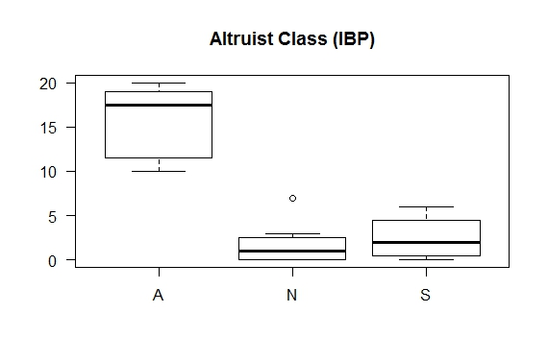

**Figure-11: Box plot of A, N, S distribution in Altruist Class (IBP)**

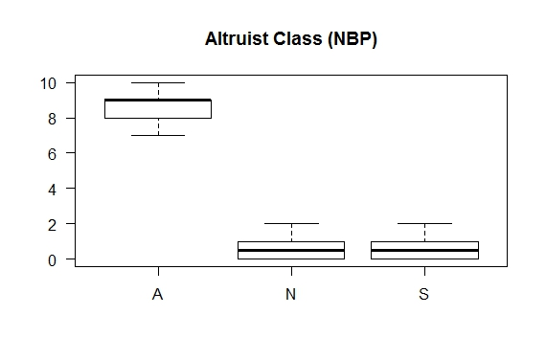

**Figure-12: Box plot of A, N, S distribution in Altruist Class (NBP)**

It can be seen here in the box plots that within the class data are quite precise. The A card data is considerably higher than the N and S cards. Since the A, N, S data are linked to the same subject, Friedman Rank Sum Test is used to see the difference between their distributions.

**Table-8: Test for difference in the A, N, S within the Altruist class**

|  |  |  |  |
| --- | --- | --- | --- |
| **Game** | **IBP** | **NBP** | |
| **Test** | Friedman Rank Sum Test | | |
| **Null Hypothesis** | There is no difference in the distribution of A, N, S within the altruist class | | |
| **Alternative Hypothesis** | There is significant difference in the distribution of A, N, S within the altruist class. | | |
| **Result** | Friedman chi-squared = 13.8621,  df = 2, p-value = 0.000977  Null hypothesis rejected | | Friedman chi-squared = 23.098,  df = 2, p-value = 9.645e-06  Null hypothesis rejected |

It can be seen above that the p-values are much less than 0.05 and hence the null hypothesis is rejected. This proves that there is significant difference in the distribution which is obvious from the box plots that the A cards median and distribution is much higher than the N and S card distributions. This shows the characteristics of the altruist class.

**Pseudo-Altruist Class:** Pseudo-altruists value handicap factor more than internal satisfaction and monetary factors. So people who qualified first cutoff, but failed to clear the second cutoff while defining the previous class will lie in this class. This is because they showed Altruist behavior but their internal satisfaction factor level is poor.

**Table-9: Cutoff point for the Pseudo-Altruist class**

|  |  |  |
| --- | --- | --- |
| **Game** | **IBP** | **NBP** |
| **Cutoff point 1** | MedianA1234i = 4; MADA1234i = 4.4478; mp1234i = 20/2=10; Cpa1i = int(max(4+4.45, 10)) = 10 (80th %) | MedianA12n = 4L; MADA12n=2.9652; mp12n=10/2 = 5  Cpa1n = int(max(4+2.97, 5)) = 7 (84th %) |
| **Cutoff point 2** | MedianA12i = 1.5; MADA12i = 2.224;  mp12i = 6/2=3;  Cpa2i = int(max(1.5+2.22, 3)) = 4 (90th %) | MedianA1n = 2L; MADA1n=1.48; mp1n=5/2 = 2.5  Cpa2n = int(max(2+1.48, 2.5)) = 3 (80th %) |
| **Pseudo-Altruist Class** | (A1234i >= 10) & (A12i < 4)  pseudo class contains 5 participants | (A1n <= 2) & (A2n >= 3)  pseudo1 class contains 7 participants |

Let us see the box plots of the pseudo-altruist class in IBP and NBP

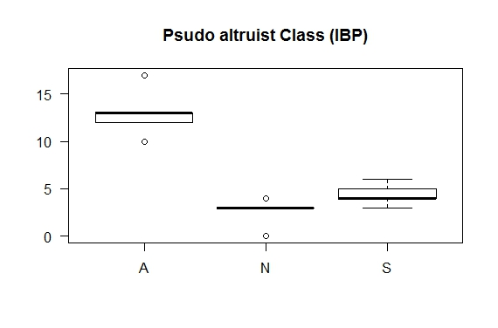

**Figure-13: Box plot of A, N, S distribution in Pseudo-Altruist Class (IBP)**

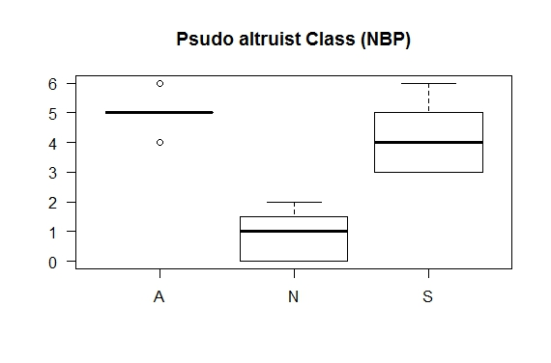

**Figure-14: Box plot of A, N, S distribution in Pseudo-Altruist Class (NBP)**

It can be seen here in the box plots that within the class data are precise. The A card data are considerably higher than the S card and which in turn is higher than N cards. Since the A, N, S data are linked to the same subject, Friedman Rank Sum Test is used to see the difference between their distributions.

**Table-10: Test for difference in the A, N, S distribution within**

**the Pseudo-Altruist class**

|  |  |  |  |
| --- | --- | --- | --- |
| **Game** | **IBP** | **NBP** | |
| **Test** | Friedman Rank Sum Test | | |
| **Null Hypothesis** | There is no difference in the distribution of A, N, S within the pseudo-altruist class | | |
| **Alternative Hypothesis** | There is significant difference in the distribution of A, N, S within the pseudo- altruist class. | | |
| **Result** | Friedman chi-squared = 10, df = 2, p-value = 0.006738  Null hypothesis rejected | | Friedman chi-squared = 12, df = 2,  p-value = 0.002479  Null Hypothesis rejected |

It can be seen above that the p-values are much less than 0.05 and hence the null hypothesis is rejected. This proves that there is significant difference in the distribution which is obvious from the box plots that the A cards median and distribution is higher than the S and N card distributions. This shows the characteristics of the pseudo-altruist class. It can be seen here that S cards are relatively high where as N cards are still lower than the altruist class. This happens because they want to play S cards but in open rounds they couldn’t do so because of the handicap factor. As you can see in the second box plot that the mean of A and S are close enough because NBP has equal number of confidential and open rounds.

**Selfish Class:** Selfish people give more importance to the monetary factor than other factors and hence play selfish card more. We will define the cutoff on total S excluding the last set (which is used to study the group behavior) using the Cp function. People qualifying this cutoff will fall in this class.

**Table-11: Cutoff point for the Selfish class**

|  |  |  |
| --- | --- | --- |
| **Game** | **IBP** | **NBP** |
| Histogram of S card played | D:\VINAYAK\Game Theory\experiment\dljp-graph\12S.jpeg | D:\VINAYAK\Game Theory\experiment\nb-graph\12S.jpeg |
| **Cutoff point** | MedianS1234i = 10; MADS1234i = 5.93; mp1234i = 20/2=10;  Cpsi = int(max(10+5.93, 10)) = 16 | MedianS12n = 5L; MADS12n=2.97; mp12n=10/2 = 5  Cpsn = int(max(5+2.97, 5)) = 8 |
| **Selfish Class** | S1234i >= 16  selfish class consist of 19 participants | S12n >= 8  selfish1 class consist of 11 participants |

Let us view the box plots of the selfish class in IBP and NBP.

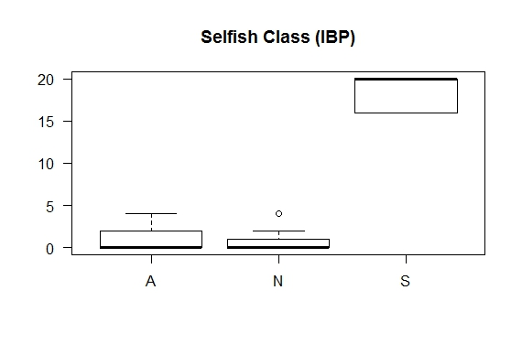

**Figure-15: Box plot of A, N, S distribution in Selfish Class (IBP)**

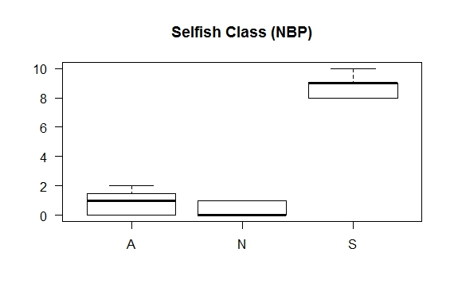

**Figure-16: Box plot of A, N, S distribution in Selfish Class (NBP)**

It can be seen here in the box plots that within the selfish class data are very precise. The S card data are considerably higher than the A and N cards. Since the A, N, S data are linked to the same subject, Friedman Rank Sum Test is used to see the difference between their distributions.

**Table-12:Test for difference in the A, N, S distribution within**

**the Selfish class**

|  |  |  |  |
| --- | --- | --- | --- |
| **Game** | **IBP** | **NBP** | |
| **Test** | Friedman Rank Sum Test | | |
| **Null Hypothesis** | There is no difference in the distribution of A, N, S within the selfish class | | |
| **Alternative Hypothesis** | There is significant difference in the distribution of A, N, S within the selfish class. | | |
| **Result** | Friedman chi-squared = 33.4462,  df = 2, p-value = 5.461e-08  Null hypothesis rejected | | Friedman chi-squared = 18.6, df = 2, p-value = 9.142e-05  Null hypothesis rejected |

It can be seen above that the p-values are much less than 0.05 and hence the null hypothesis is rejected. This proves that there is significant difference in the distribution which is obvious from the box plots that the S cards median and distribution is much higher than the A and N card distributions. This shows the characteristics of the selfish class. This happens because they rate monetary factor higher than other factors in the utility function and tend to play S cards most of the time.

**Indecisive Class:** There are few people who are not able to decide and fix up the values of internal satisfaction, handicap and monetary factors. Such people play N card many a times because of their indecisive nature. We use our same Cp function on total N (excluding the last set) to define this class.

**Table-13: Cutoff point for the Indecisive class**

|  |  |  |
| --- | --- | --- |
| **Game** | **IBP** | **NBP** |
| Histogram of N card played | D:\VINAYAK\Game Theory\experiment\dljp-graph\1234N.jpeg | D:\VINAYAK\Game Theory\experiment\nb-graph\12N.jpeg |
| **Cutoff point** | MedianN1234i = 3.5; MADN1234i = 3.7; mp1234i = 20/2=10;  Cpni = int(max(3.5+3.7, 10)) = 10 | MedianN12n = 1L; MADN12n= 1.48; mp12n=10/2 = 5  Cpnn = int(max(1+1.48, 5)) = 5 |
| **Indecisive Class** | N1234i >= 10  indecisive class consist of 4 participants | N12n >= 5  indecisive1 class consist of 3 participants |

Let us see the box plots of distribution of the indecisive class in IBP and NBP.

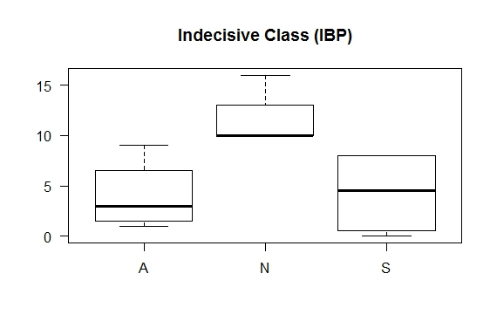

**Figure-17: Box plot of A, N, S distribution in Indecisive Class (IBP)**

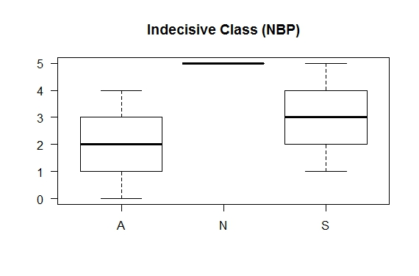

**Figure-18: Box plot of A, N, S distribution in Indecisive Class (NBP)**

It can be seen here in the box plots that within the indecisive class data are precise especially for N cards. The N card data are considerably higher than the A and S cards. Since there are only 4 participants in IBP game and 3 participants in NBP game in the indecisive class, no statistical analysis on this class separately would be meaningful. However, the box plots clearly shows that N card median and distribution are distinctly higher than the A and S card. This shows characteristics of the indecisive class.

**Fluctuating Class:** There are a good number of participants who don’t belong to any of the classes mentioned above because they are not consistent. They frequently change their choice and affected by the environment. They belong to this fluctuating class. Notice that all the classes we have defined are mutually exclusive i.e no person can lie in more than one class.

**Table-14: Cutoff point for the Fluctuating class**

|  |  |  |
| --- | --- | --- |
| **Game** | **IBP** | **NBP** |
| **Fluctuating Class** | (A1234i < 10) & (N1234i<10) & (S1234i<16)  fluctuating class consist of 46 participants | (A12n < 7|A1n<3)& (N12n < 5) & (S12n < 8) & (A1n>2|A2n<3)  fluctuating1 class consist of 50 participants |

Let us see the box plots of the A, N, S distribution within the fluctuating class in IBP and NBP game.

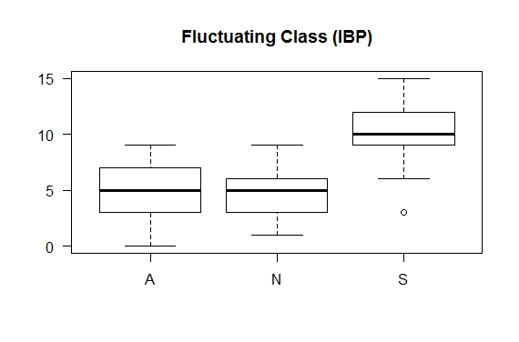

**Figure-19: Box plot of A, N, S distribution in Fluctuating Class (IBP)**

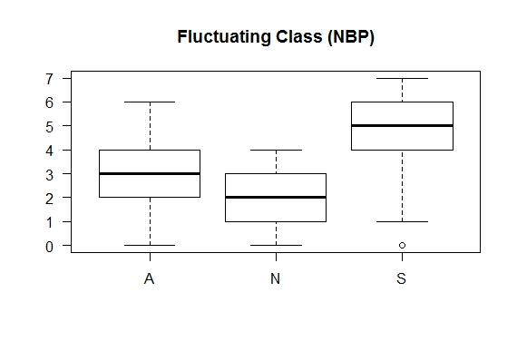

**Figure-20: Box plot of A, N, S distribution in Fluctuating Class (NBP)**

It can be seen here in the box plots that within the fluctuating class data are not very precise. There is not much difference between the levels. The distribution shows leniency of the people of the class towards selfish card. Since the A, N, S data are linked to the same subject, Friedman Rank Sum Test is used to see the difference between their distributions.

**Table-15: Test for difference in the A, N, S distribution within**

**the Fluctuating class**

|  |  |  |  |
| --- | --- | --- | --- |
| **Game** | **IBP** | **NBP** | |
| **Test** | Friedman Rank Sum Test | | |
| **Null Hypothesis** | There is no difference in the distribution of A, N, S within the fluctuating class | | |
| **Alternative Hypothesis** | There is significant difference in the distribution of A, N, S within the fluctuating class. | | |
| **Result** | Friedman chi-squared = 48.2171,  df = 2, p-value = 3.387e-11  Null hypothesis rejected | | Friedman chi-squared = 36.9392,  df = 2, p-value = 9.522e-09  Null hypothesis rejected |

It can be seen above that the p-values are much less than 0.05 and hence the null hypothesis is rejected. This proves that there is significant difference in the distribution which is obvious from the box plots that the S cards median and distribution is higher than the A and N card distributions. Though the difference is not so prominent as in the selfish class. This shows the characteristics of the fluctuating class which is inclined towards the S card.

1. **Test of distribution of different classes:**

Five different classes have been identified here with different characteristics. All these classes are not linked to each other and are non-parametric. Also the classes are more than two hence Kruskal-Wallis rank sum test is done here to test the difference between the different classes.

**Distribution of A:**

Let us first see the box plots of the A distribution for various classes.

**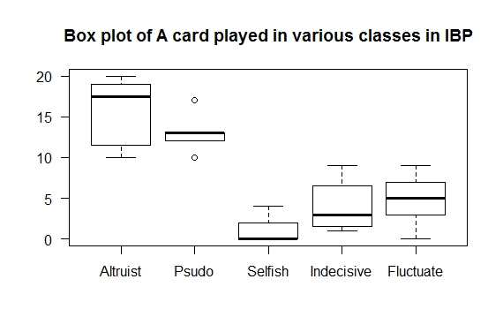**

**Figure-21: Box plot of A card played in different classes (IBP)**

**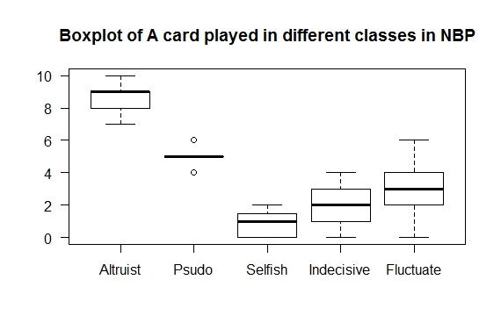**

**Figure-22: Box plot of A card played in different classes (NBP)**

It is evident from the above box plots that the pattern of the A card distribution is similar in both the IBP and NBP games. As per the characteristics altruist class is at the distinctly highest level because of their high valuation of internal satisfaction factor in the utility function. Then comes the pseudo-altruist class which also plays considerable number of times A card more in the open rounds, where handicap factor is more prominent. After that the fluctuating class comes where people are often changing their decisions affected by the environment. So, they don’t assign a fix value to the factors throughout the game. After that comes the indecisive class where people are not able to decide and play the N card most. The selfish class is at the lowest level because of the obvious reason that the people there give more importance to the monetary factor than the other factors in the utility function.

**Table-16: Test for difference in the A card played**

**by the various class people**

|  |  |  |  |
| --- | --- | --- | --- |
| **Game** | **IBP** | **NBP** | |
| **Test** | Kruskal-Wallis Rank Sum test | | |
| **Null Hypothesis** | There is no difference in the distribution of the A card played by the various classes. | | |
| **Alternative Hypothesis** | There is significant difference in the distribution of the A card played by various classes. | | |
| **Result** | Kruskal-Wallis chi-squared = 53.037, df = 4, p-value = 8.372e-11  Null hypothesis rejected | | Kruskal-Wallis chi-squared = 55.0948, df = 4, p-value = 3.104e-11  Null hypothesis rejected |

It can be seen above that the p-values are much less than 0.05 and hence null hypothesis is rejected. It proves that there is considerable and significant difference between the levels of the A card amongst the classes, which is also evident from their box-plot diagrams.

**Distribution of S:**

Let us see the box plots of the S distributions for various classes.

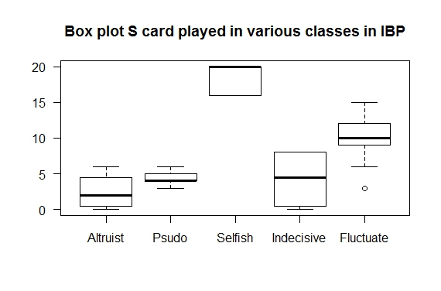

**Figure-23: Box plot of S card played in different classes (IBP)**

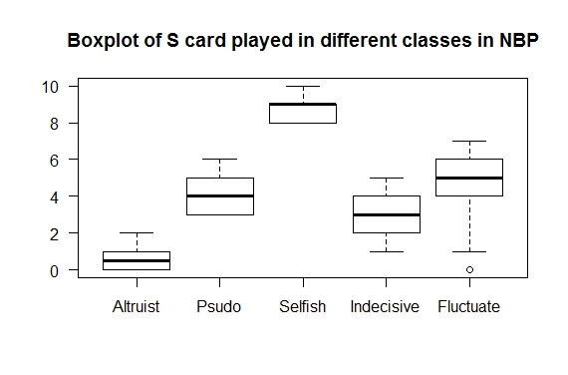

**Figure-24: Box plot of S card played in different classes (NBP)**

It can be seen in the above box plots that the pattern of the S card distribution is similar in both the IBP and NBP games. As per the characteristics altruist class is at the distinctly lowest level because of their high valuation of internal satisfaction factor in the utility function. The selfish class is at the top in playing the S card for the obvious reason of giving importance to the monetary factor. Other classes are in between.

**Table-17: Test for difference in the S card played**

**by the various class people**

|  |  |  |  |
| --- | --- | --- | --- |
| **Game** | **IBP** | **NBP** | |
| **Test** | Kruskal-Wallis Rank Sum test | | |
| **Null Hypothesis** | There is no difference in the distribution of the S card played by the various classes. | | |
| **Alternative Hypothesis** | There is significant difference in the distribution of the S card played by various classes. | | |
| **Result** | Kruskal-Wallis chi-squared = 62.235, df = 4, p-value = 9.831e-13  Null hypothesis rejected | | Kruskal-Wallis chi-squared = 54.3125, df = 4, p-value = 4.526e-11  Null hypothesis rejected |

It can be seen above that the p-values are much less than 0.05 and hence null hypothesis is rejected. It proves that there is considerable and significant difference between the levels of the S card amongst the classes, which is also evident from their box-plot diagrams.

**Distribution of N:**

Let us see the box plots of the N distributions for various classes.

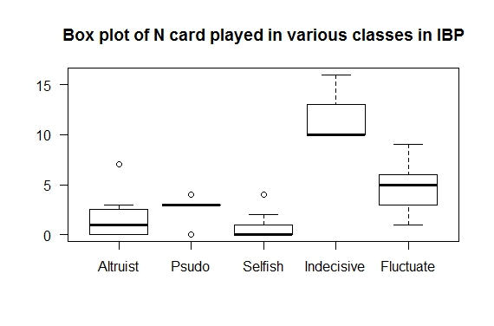

**Figure-25: Box plot of N card played in different classes (IBP)**

**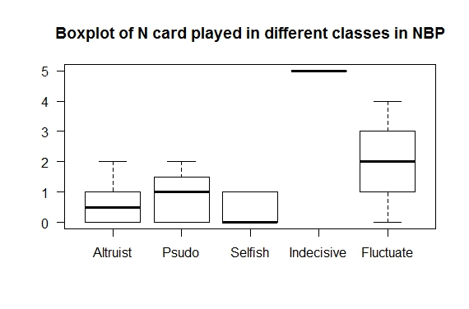**

**Figure-26: Box plot of N card played in different classes (NBP)**

It can be seen in the above box-plot diagrams that the distribution and pattern of N levels are similar in both the games. The indecisive class is at the top in playing N cards since they are not able to decide. Incidentally they are quite precise also. One of the reasons of their precision is their low number. The altruists and selfish class people are very clear in deciding their values for their different factors in the utility function; hence they don’t have confusion and are at the lowest levels. The fluctuating class while shifting from A to S and S to A might be in some dilemma and play some times N. The pseudo-altruist hesitates to play S card in the open rounds and at the same time they don’t want to lose their money, hence they play N card some times. This may be the reason that the fluctuating class and the pseudo-altruist class are in the middle.

**Table-18: Test for difference in the N played by various class people**

|  |  |  |  |
| --- | --- | --- | --- |
| **Game** | **IBP** | **NBP** | |
| **Test** | Kruskal-Wallis Rank Sum test | | |
| **Null Hypothesis** | There is no difference in the distribution of the N card played by the various classes. | | |
| **Alternative Hypothesis** | There is significant difference in the distribution of the N card played by various classes. | | |
| **Result** | Kruskal-Wallis chi-squared = 47.690, df = 4, p-value = 1.095e-09  Null hypothesis rejected | | Kruskal-Wallis chi-squared = 29.1923, df = 4, p-value = 7.145e-06  Null hypothesis rejected |

It can be seen above that the p-values are much less than 0.05 and hence null hypothesis is rejected. It proves that there is considerable and significant difference between the levels of the N card amongst the classes, which is also evident from their box-plot diagrams.

**(vii)Test of Group Behavior:** The last set of both the games IBP (5th set) and NBP (3rd set) are played by the participants forming their own groups depicting their group behavior. We can test the difference in behavior between the 4th and 5th set of IBP and between the 2nd and 3rd set of NBP. Since this is a paired test between two non-parametric distributions, Wilcoxon Rank Sum test would be more appropriate.

**Table-19: Test for difference in the A card played in 4th and 5th sets in IBP and 2nd and 3rd sets in NBP**

|  |  |  |  |
| --- | --- | --- | --- |
| **Game** | **IBP** | **NBP** | |
| **Test** | Wilcoxon Rank Sum test | | |
| **Null Hypothesis** | There is no difference in the distribution of the A card played between 4th and 5th set in IBP. | There is no difference in the distribution of the A card played between 2nd and 3rd set in NBP. | |
| **Alternative Hypothesis** | There is significant difference in the distribution of the A card played between 4th and 5th set in IBP. | | There is significant difference in the distribution of the A card played between 2nd and 3rd set in NBP. |
| **Result** | V = 886, p-value = 0.997  Null hypothesis failed to be rejected | | V = 526, p-value = 0.5107  Null hypothesis failed to be rejected |

It can be seen in the above table that p-values are much higher than the 0.05 and hence the null hypothesis failed to be rejected. Let us examine the N and S card distribution also in this respect.

**Table-20: Test for difference in the N card played in 4th and 5th sets in IBP and 2nd and 3rd sets in NBP**

|  |  |  |  |
| --- | --- | --- | --- |
| **Game** | **IBP** | **NBP** | |
| **Test** | Wilcoxon Rank Sum test | | |
| **Null Hypothesis** | There is no difference in the distribution of the N card played between 4th and 5th set in IBP. | There is no difference in the distribution of the N card played between 2nd and 3rd set in NBP. | |
| **Alternative Hypothesis** | There is significant difference in the distribution of the N card played between 4th and 5th set in IBP. | | There is significant difference in the distribution of the N card played between 2nd and 3rd set in NBP. |
| **Result** | V = 1267, p-value = 0.02077  Null hypothesis rejected | | V = 357, p-value = 0.005522  Null hypothesis rejected |

**Table-21: Test for difference in the S card played in 4th and 5th sets in IBP and 2nd and 3rd sets in NBP**

|  |  |  |  |
| --- | --- | --- | --- |
| **Game** | **IBP** | **NBP** | |
| **Test** | Wilcoxon Rank Sum test | | |
| **Null Hypothesis** | There is no difference in the distribution of the S card played between 4th and 5th set in IBP. | There is no difference in the distribution of the S card played between 2nd and 3rd set in NBP. | |
| **Alternative Hypothesis** | There is significant difference in the distribution of the S card played between 4th and 5th set in IBP. | | There is significant difference in the distribution of the S card played between 2nd and 3rd set in NBP. |
| **Result** | V = 742, p-value = 0.1004  Null hypothesis failed to be rejected | | V = 466, p-value = 0.286  Null hypothesis failed to be rejected |

We can see here that comparison between the last and last but one sets in both the games show that there is no significant difference between the A and S levels. But there is significant difference in the N level. This reveals a very important group behavior. The participants who were indecisive and fluctuating and were playing N cards many a times have changed their decision as per the group effect and either have gone to A level or to S level. Since the N cards are distributed in A and S cards probably approximately evenly in the same ratio, the difference in neither is significant. This fact can also be verified in the histograms of the S card and N card distribution given in figure-5,6 and 9,10. The N card blocks have diminished in the last set, where as S card blocks have become bipolar.

**Discussion:**

It can be seen above in analysis that we have conducted two different experiments in our analysis, the initial Bliss vs Pleasure (IBP) game and the new Bliss vs Pleasure (NBP) game. So our experiment can be divided into two phases. When the IBP game data was analyzed it figured out that a few sets in the IBP game were nearly redundant so they were merged while designing the NBP game as given in the materials and method section.

Aim of our experiment was to study the factors that lead to cooperation in the society. For this we hypothesized that some people cooperate for their internal satisfaction “True Altruist” while others for their social status or as part of costly signaling “Pseudo Altruist”. Now it can be seen in our analysis section that we assumed that there exists, a utility function corresponding to each individual, which has three factors in it, the internal satisfaction factor, handicap factor and the monetary factor. We proved the existence of the factors with the help of chi-squared goodness of fit test. (Proof by contradiction).

Based on this utility function we classified our sample into five different classes- altruist, pseudo-altruist, selfish, indecisive and fluctuating class. Each class has been discussed above separately.

It can be seen in this experiment that majority of people fall in the fluctuating class, some in altruist, some in selfish and a few in the indecisive class. As it was mentioned earlier that majority of people in society are neutral is isomorphic to the union of indecisive and fluctuating class of our experiment. We have discussed above that and further classify these neutral people into indecisive and fluctuating class. In fact there are only few people in the society who are actually not able to take decisions because of their mental status, some illness or low i.q. Majority of them belong to the fluctuating class where people change their decisions frequently because of various forces acting on the society. For instance in the freedom struggle case most of the people wanted their country to be free but were scared of the British government. In our game they are isomorphic to persons who want to do something for the poor children deep down the heart but at the same time scared of losing their money. These types of people plays a mixture of A, N and S. They play S to recover the money they have donated by playing A previously. It might be the case that the person is a bit greedy but at the same time wants his country to be free. So he is unable to decide whether to go with the government and seek reward from them or help his countrymen in freedom struggle. He is isomorphic to an individual who want to help the poor, but at the same time also tempted to get the temptation amount by playing more number of S cards and hence increasing his probability for winning it. So he plays a mixture of A and S cards in the game. Hence these lie in fluctuating class of our game. Similarly people participating actively in freedom struggle are isomorphic to Altruist class or Pseudo Altruist class if there exists, a possibility of gaining reputation or political goals by doing so. Whereas people engaged in government service or helping the rulers are isomorphic to Selfish class people. What great people like Mahatma Gandi, Bhagat Singh and others did that they were able inspire this class by their words and action. They were able to motivate this fluctuating class people which constitute the majority of population (nearly 50% in our samples) to their side.

Now let us compare our Bliss vs Pleasure game with other repetitive games modeling the society. For reference we will call Bliss vs Pleasure game as NBP. In the gift exchange or trust game or public good experiment reward mechanism is used. In third party ultimatum game or prisoner’s dilemma or some variant of public good experiment punishment mechanism and strong reciprocity are used. If we compare these games with NBP the mechanism seems to be in contrast to the strong reciprocity. If we consider any corrupt society, we normally see that the selfish people get reward and cooperators and altruists are punished. The selfish people or defectors generally make their own group and use politics to punish the cooperators or altruists to stop them from giving any punishment or expose them and gain in the long run. This situation is depicted in the NBP game. If at all any example of strong reciprocity is seen in our country, it is seen as third party being government or police. We see that sometimes they are also corrupt. But the important factor which has emerged in the NBP game is the Internal Satisfaction Factor (ISF), which is unique. It is this ISF which gives strength to the altruists to fight against evils. It was this factor which worked within the freedom fighters such as Mahatma Gandhi, or Bhagat Singh or the reformers such as Jesus Christ or Mahatma Buddha. It was this factor which made so many followers of these enlightened persons because no strong mechanism or reward mechanism can be found out in extreme situations.

**References**

Alexander, R. D. (1987). The Biology of Moral Systems (Aldine De Gruyter, New York)

Adolphs R (2003), Cognitive neuroscience of human social behavior, Nat Rev Neurosci, 4:165-178.

Axelrod, R. and Hamilton, W.D. (1981). The evolution of cooperation. Science, 211, 1390-1396

Bendor, J. & Swistak, P. (2001), The evolution of norms, Am. J. Sociol. 106, 1493-1545

Briggs, K., Workman, J.P. Jr, and York, A.S. (2013). Collaborating to Cheat: A Game Theoretic Exploration of Academic Dishonesty in Teams. Academy of Management Learning & Education, 12, 4-17

Cooper, R., Dejong, D.V., Forsythe, R., and Ross, T.W. (1996). Cooperation without Reputation: Experimental Evidence from Prisoner’s dilemma games. Games and Economic Behavior 12(2), 187-218

Fehr, E., Kirchsteiger, G. & Riedl, A. (1993), Does fairness prevent market clearing? An experimental investigation. Q. J. Econ. 108, 437-459

Fehr, E. & Schmidt, K. M. (1999), A theory of fairness, competition, and cooperation. Q. J. Econ. 114, 817-868

Gintis, H., Smith, E.A. & Bowles (2001). Costly signaling and cooperation. J. Theoretical Biology 213, 103-119

Hayashi, N., Ostrom, E., Walker, J. & Yamagishi, T. (1999), Reciprocity, trust, and the sense of control--a cross-societal study. Rational. Soc. 11, 27-46

Hill, K. (2002), Altruistic cooperation during foraging by the Ache, and the evolved human predisposition to cooperate. Hum. Nat. 13, 105-128

Hoffman, E., McCabe, K., Shachat, K. & Smith, V. (1994), Preferences, property rights and anonymity in bargaining games. Game Econ. Behav. 7, 346-380

Kaplan, H., Hill, J., Lancaster, J. & Hurtado, A. M. (2000), A theory of human life history evolution: diet, intelligence, and longevity. Evol. Anthropol. 9, 156-185

Leimar, O. & Hammerstein, P. (2001). Evolution of cooperation through indirect reciprocity. Proc. R. Soc Lond. B 268, 745-753

McCabe K, Houser D, Ryan L, Smith V and Trouard T (2001), A functional imaging study of cooperation in two-person reciprocal exchange., Proc Natl Acad Sci USA, 98:11832-11835

Nowak, M. A. & Sigmund, K. (1998). Evolution of indirect reciprocity by image scoring. Nature 393, 573-577

Nowak, M. A., Page, K. M. & Sigmund, K. (2000). Fairness versus reason in the ultimatum game. Science 289, 1773-1775

Nowak, M., and Sigmund,K., (1993). Chaos and the evolution of cooperation. Proc. Natl. Acad. Sci. USA. 90, 5091-5094

Ostrom, E., Walker, J. & Gardner, R. (1992), Covenants with and without a sword: self-governance is possible. Am. Polit. Sci. Rev. 86, 404-417

Roberts, G. (1998). Competitive altruism: from reciprocity to the handicap principle . The Royal Society

Sally, D. (1995). Conversation and Cooperatio in Social Dilemmas: A Meta-Analysis of Experiments from 1958 to 1992. Rationality and Society 1995 7: 58

Sanfey AG, Rilling JK, Aronson JA, Nystrom LE, Cohen JD (2003), The neural basis of economic decision-making in the ultimatum game. Science, 300:1755-1758

Sethi, R. & Somanathan, E. (1996), The evolution of social norms in common property resource use. Am. Econ. Rev*.* 86, 766-788

Trivers, R.L., (1971). The evolution of reciprocal altruism. Q. Rev. Biol., 46, 35-57

Yamagishi, T. (1986), The provision of a sanctioning system as a public good. J. Pers. Soc. Psychol. 51, 110-116

Zahavi, A. (1977). The testing of a bond. Animal Behavior 25, 246-247

Zahavi, A. (1987). The theory of signal selection and some of its implications. In: Delfino, V. P. (ed.). Proc. Intern. Symp. Biol. Evolution. Adriatica Editrica, Bari, 305-327

Zahavi, A. (1995). Altruism as Handicap: The Limitations of Kin Selection and Reciprocity. Journal of Avian Biology, 26, 1-3