Home > Pune > Pune: IISER's 10th convocation held; 308 students receive degrees

Pune: IISER's 10th convocation held; 308 students receive degrees

Dr. Anil Kakodkar Chairman, Rajiv Gandhi Science and Technology Commission and Former Chairman, Atomic Energy Commission was the Chief Guest for the occasion.
FPJ Web DeskUpdated: Wednesday, May 31, 2023, 10:24 PM IST

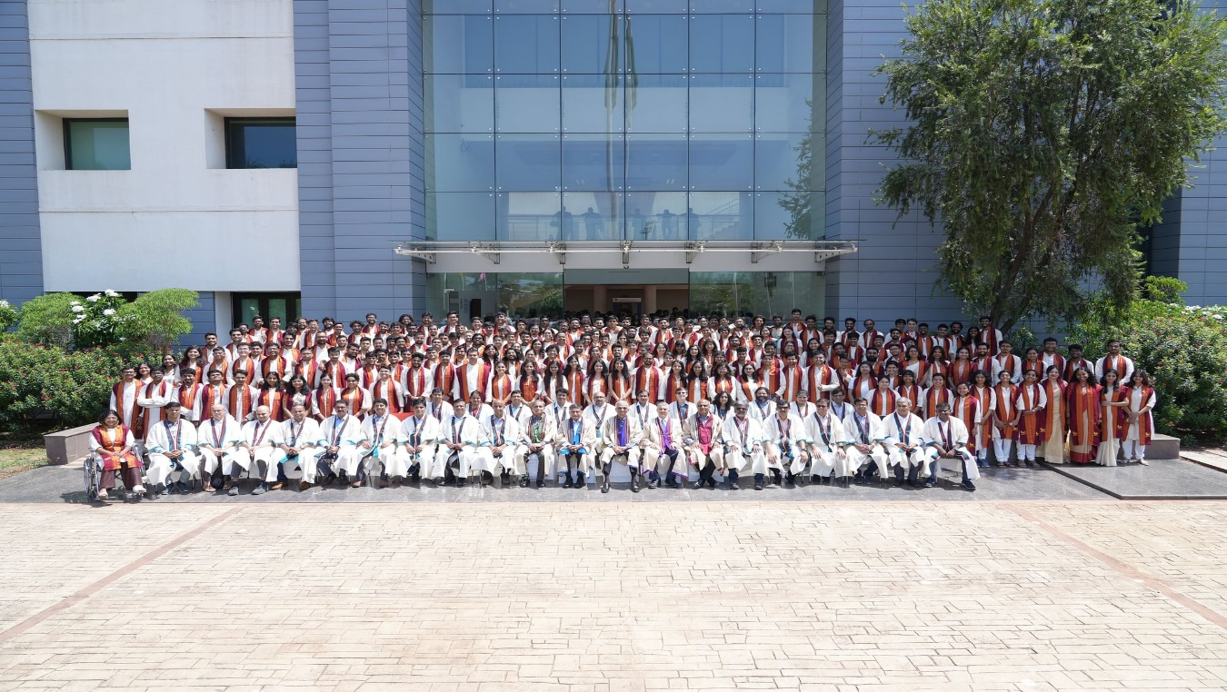
Pune: IISER's 10th convocation held; 308 students receive degrees
In the 10th convocation of IISER Pune held on Wednesday, a total of 308 students received their degrees. This included 45 students graduating with PhD degrees, 25 with Master’s and PhD dual degrees, 14 with Master’s degrees, 207 with BS and MS dual degrees, and 17 with BS degrees.
Dr. Anil Kakodkar Chairman, Rajiv Gandhi Science and Technology Commission and Former Chairman, Atomic Energy Commission was the Chief Guest for the occasion.
At the outset of the event, Director Professor Sunil S. Bhagwat presented degrees to all graduates. Seventeen BS-MS students received their degrees with Distinction (CGPA >9). BS-MS student Mihir Neve received the institute gold medal.
Academic awards
Chief Guest Dr Anil Kakodkar presented the best MS and PhD thesis awards. PhD students Manesh Prakash Joshi (Biology); Tariq Ahmad Sheikh (Chemistry); Sushant Saryal (Physics); and Saikat Panja (Mathematics) received the Xytel Best PhD Best Thesis Awards; and BS-MS students Avadhoot Sandeep Jadhav (Biology); Venkata Sai Sreyas Adury (Chemistry); Anuja Raorane (Earth and Climate Science); Chapke Rashmi Sanjayrao (Data Science); Shrijay Sutar (Humanities and Social Sciences); Ajaykrishnan E.S. (Mathematics); Rhutwik Skanda (Physics) received the Xytel Best MS Thesis Awards.
Annual report
IISER Pune Director Prof. Sunil Bhagwat presented the annual report of the institute and described the academic achievements of institute members. Prof. Bhagwat noted the various scientific events pursued by the institute researchers throughout the year and the many extracurricular activities pursued by student-led clubs at the institute.

Convocation address
In his convocation address, Chief Guest Dr Anil Kakodkar noted the distinctive contributions of IISERs to science education and research in India. He spoke about the role of science and technology higher education in the development of the country, especially in the context of economic prosperity, human wellness, and security, which Dr Kakodkar referred to as the three pillars of national development.
"To be effective in this context, our knowledge institutions must be both knowledge creators as well as value creators and inculcate such an aptitude and capability in our students through broad-based learning and practice environment," he said.
Dr Kakodkar said that to be a front-runner globally, we need to be aware of the need to bridge disparity gaps such as the urban-rural gap. Dr Kakodkar said that the emerging era of the knowledge-driven economy provides a great opportunity for the transformation of the rural horizon that could bridge the urban-rural divide and contribute to a major boost to the Indian economy.
With these ideas and suggestions about how one can contribute productively to the country's development, Dr Kakodkar extended his best wishes to the graduates. "I do hope that as you rise, you will retain in you a spirit of trusteeship and contribute substantially to your roots, the society around you, the institutions that brought you up and the nation at large. It is this spirit of trusteeship and the desire to support others who were not as fortunate or as successful as us that makes this world a better place," Dr Kakodkar said.

